## PHP

With pure **HTML web pages**, the server simply serves **static HTML** that only display content. PHP is used to turn the web sites into interactive web application.

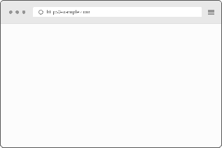  



Fig 1: Web Server 🡪 Static HTML File 🡪 Client Web Browser

With **PHP** in the mix, the web server is able to **dynamically generate HTML** web pages

   





Fig 2: Web Server 🡪 PHP 🡪 MySQL 🡪 PHP 🡪 Client Web Server

**PHP**: **Personal Home Pages**, it was later changed **PHP Hypertext Processor**.

**PHP**: **Server-side programming language** – it runs on a web server.

### Simple Form(Form.html)

<!doctype html>

<**html**>

<**head**>

<**meta** charset = "UTF-8"/>

<**title**> Simple Form </**title**>

</**head**>

<**body**>

<**p**> Please fill out the form </**p**>

<**img** src = "database.png" width = "100" height = "175"

alt = "database picture"/><**br**/>

<**form** method = "post" action = "khan.photon@gmail.com">

<**label** for = "firstname"> First Name: </**label**>

<**input** type = "text" id = "filename" name = "firstname"/><**br**/>

<**label** for = "lastname"> Last Name: </**label**>

<**input** type = "text" id = "lastname" name = "lastname"/><**br**/>

<**label** for = "email"> Email: </**label**>

<**input** type = "email" id = "email" name = "email"/><**br**/>

<**label** for = "gender">Gender: </**label**>

Male <**input** type = "radio" id ="gender" name = "gender" value = "male">

Female <**input** type = "radio" id = "gender" name = "gender"

value = female"><**br**/>

<**label** for = "description"> Description: </**label**>

<**textarea** name = "description"> Max word 500 words </**textarea**><**br**/>

<**input** type = "submit" value = "Submit" name = "submit"/>

</**form**>

</**body**>

</**html**>

Code 1 (Form.html): Simple Form HTML Code

**Tags:** <**form**></**form**>, <**input></input>,** <**label></label>**

**Attributes**: action, type, id, method, name, class, value

### Breakdown(Form.html)

Basic HTML Format

<!doctype html>

<**html**>

<**head**>

<**meta** charset = "UTF-8"/>

<**title**> Simple Form </**title**>

</**head**>

<**body**>

</**body**>

</**html**>

|  |  |
| --- | --- |
| **Labels/Tags** | **Description** |
| <!doctype html> | A document type declaration |
| <**html**> | Tells the browser that this is an HTML document |
| <**head**></**head**> | Includes title for the document, scripts, styles, meta information |
| <**meta** charset="UTF-8"/> | Specifies what character set is our website written with |
| "UTF-8" | Universal Character Set + Transformation Format 8-bit |
| <**body**></**body**> | This is where all the HTML contents are written |
| <**p**></**p**> | Paragraph |
| <**img** src="database.png"/> | Include Image, Attribute src is the image src path |
| alt="database picture" | Alternatively, text will show up if no image found |
| width="100" height="175" | Fixing the width and height of the image |

<**form** method = "post" action = "khan.photon@gmail.com">

Form action attribute should be changed

<**form** method = "post" action = "report.php"></**form**>

Form tag causes the PHP script to run on the server.

|  |  |
| --- | --- |
| **Labels/Tags** | **Description** |
| <**input><**/**input>** | Input tag is the input field where user can enter data |
| type="text | Attribute type is the value received and saved from the user |
| id="filename" | Attribute id is the unique identifier; used for manipulating the element |
| name="firstname" | Attribute name is the value received and saved from the user |

<**label** for = "gender">Gender: </**label**>

Male <**input** type = "radio" id ="gender" name = "gender" value = "male">

Female <**input** type = "radio" id = "gender" name = "gender" value = "female">

Label tag allows user clicks on the text within the <**label>** element, it toggles the control.

For attribute should be equal to the id attribute of the related element to bind together

<**textarea** name = "description"> Max word 500 words </**textarea**><**br**/>

Textarea tag allows users to type multi-lines, description type situations

<**input** type = "submit" value = "Submit" name = "submit"/>

Type attribute allows user to make a submit button

Value attribute allows user to change the text in the submit button

<**br**/>

It allows the display go to next line. Single line break.

### Confirmation(Report.php)

<?php

**if**(!empty($_POST["submit"])):

$firstname = $_POST["firstname"];

$lastname = $_POST["lastname"];

$email = $_POST["email"];

$gender = $_POST["gender"];

$description = $_POST["description"];

**echo** "First Name: ".$firstname."<br/>";

**echo** "Last Name: ".$lastname."<br/>";

**echo** "Email: ".$email."<br/>";

**echo** "Gender: ".$gender."<br/>";

**echo** "Description: ".$description."<br/>";

**endif**;

?>

Code 2 (Report.php): Receiving the user input information from form.html

### Breakdown(Report.php)

|  |  |
| --- | --- |
| **Labels/Tags** | **Description** |
| <?php ?> | It indicates that the PHP code is written in this block |
| **If**(condition): | If the condition is true, do the following statement |
| $_POST["submit"] | $_POST receives the value from the name attribute |
| $firstname | $ creates the variable |
| **echo** | Outputting information beyond the confines of the <?php ?> |

Web browser know nothing about PHP and, therefore, have no ability to run PHP scripts.

Web servers with PHP support are equipped to run PHP scripts and turn them into HTML web pages that browsers can understand.

Every PHP must end with a semicolon “;”.

Name the PHP file with “.php”

### PHP Information(info.php)

<?php

phpinfo();

?>

Code 3 (Info.php): Detailed information about the PHP installed in the PC

### Variable

* PHP variable names must begin with a dollar sign, and cannot contain spaces
* The first character after the dollar be a letter or an underscore “_”
* Characters after the first character after that can be a **letter, an underscore, or a number**
* Spaces and special characters are not allowed in any part of a variable name
* Use all lowercase for variable name
* Separate words in a multi-word variable name with underscores

### Assigning value to the variable

$description = “I am the man.”;

Pieces of text(strings) must be enclosed by quotes, either single quotes or double quotes.

### Special Variable

$_POST is a special variable that is known as a superglobal. It is a collection of storage locations used to hold data from a web form. It is also an **array**. This array is filled the values the user entered into the form.

### Concatenation

**echo** "Description: ".$description."<br/>";

The period allows us to stick multiple strings of text together as one. This process is known as concatenation.

<?php

$name = "Jack Stubbort";

$age = "17";

$place = "Netherland";

$msg = $name."is ".

$age."-years-old. "

."He works in ".$place.".";

**echo** $msg;

?>

Code 4 (Concatenation.php): Long line of PHP codes spanned across multiple lines

### Escape Characters

* Escape characters in PHP starts with a backlash “\”
* Escape characters can be escaped in double-quoted only
* Single-quoted string only allow ‘\’ but not ‘\\’

<?php

$name = "Allen Smith";

$age = "21";

$occupation = "Engineer";

**echo** '$name is $age-years-old. \r\n He is an \"$occupation.\"';

**echo** "<br/><br/>";

**echo** nl2br("**$name** is **$age**-years-old. **\n** He is an **\"$occupation**.**\"\n\n**");

**echo** "**\\** **\"**";

?>

Code 5 (DoubleSingle.php): Escape Characters.

For newline break, we need to use nl2br() function to go new line.

### Mailing

#### Initial Setup

We can send mail from localhost with sendmail package, sendmail package is inbuild in XAMPP. So, if we are using XAMPP then you can easily send mail from localhost.

For example: We can configure C:\xampp\php\php.ini and c:\xampp\sendmail\sendmail.ini for gmail to send mail.

In C:\xampp\php\php.ini find extension=php_openssl.dll and remove the semicolon from the beginning of that line to make SSL working for gmail for localhost.

In php.ini file find [mail function] and change

SMTP=smtp.gmail.com

smtp_port=587

sendmail_from = my-gmail-id@gmail.com

sendmail_path = "\"C:\xampp\sendmail\sendmail.exe\" -t"

Now Open C:\xampp\sendmail\sendmail.ini. Replace all the existing code in sendmail.ini with following code

[sendmail]

smtp_server=smtp.gmail.com

smtp_port=587

error_logfile=error.log

debug_logfile=debug.log

auth_username=my-gmail-id@gmail.com

auth_password=my-gmail-password

force_sender=my-gmail-id@gmail.com

Now you have done!! create php file with mail function and send mail from localhost.

PS: Don't forgot to replace my-gmail-id and my-gmail-password in above code. Also, don't forget to remove duplicate keys if you copied settings from above. For example comment following line if there is another sendmail_path : sendmail_path="C:\xampp\mailtodisk\mailtodisk.exe" in the php.ini file

Also remember to restart the server using the XAMMP control panel so the changes take effect.

For gmail please check [**https://support.google.com/accounts/answer/6010255**](https://support.google.com/accounts/answer/6010255%20) to allow access from less secure apps.

**Source:** [**https://stackoverflow.com/questions/15965376/how-to-configure-xampp-to-send-mail-from-localhost**](https://stackoverflow.com/questions/15965376/how-to-configure-xampp-to-send-mail-from-localhost)

### Mailing(Mail.php)

<?php

**echo** '<!doctype html>';

**echo** ' <html>';

**echo** ' <head>';

**echo** ' <meta charset = "UTF-8"/>';

**echo** ' <title> Simple Form </title>';

**echo** ' </head>';

**echo** ' <body>';

**echo** ' <img src = "images/database.png" width = "100" height = "100"';

**echo** ' alt = "database picture"/><br/>';

**echo** ' <p> Please fill out the form </p>';

**echo** ' <form method = "post" action = "';

**echo** $_SERVER['PHP_SELF']."**\"**>";

**echo** ' <label for = "firstname"> First Name: </label>';

**echo** ' <input type = "text" id = "filename" name = "firstname"/><br/>';

**echo** ' <label for = "lastname"> Last Name: </label>';

**echo** ' <input type = "text" id = "lastname" name = "lastname"/><br/>';

**echo** ' <label for = "email"> Email: </label>';

**echo** ' <input type = "email" id = "email" name = "email"/><br/>';

**echo** ' <label for = "gender">Gender: </label>';

**echo** ' Male <input type = "radio" id ="gender" name = "gender" value = "male">';

**echo** ' Female <input type = "radio" id = "gender" name = "gender" value = "female"><br/>';

**echo** ' <label for = "description"> Description: </label>';

**echo** ' <textarea name = "description"> Max word 500 words </textarea><br/>';

**echo** ' <input type = "submit" value = "Submit" name = "submit"/>';

**echo** ' </form>';

**echo** ' </body>';

**echo** ' </html>';

?>

Code 6 (Mail.php): First Section.

Form.html file has been converted to PHP file by adding echo.

$_SERVER['PHP_SELF']

The form sends the data to the same page and not directing to another PHP file.

<?php

**if**(!**empty**($_POST["submit"])):

$firstname = $_POST["firstname"];

$lastname = $_POST["lastname"];

$email = $_POST["email"];

$gender = $_POST["gender"];

$description = $_POST["description"];

**echo** "First Name: ".$firstname."<br/>";

**echo** "Last Name: ".$lastname."<br/>";

**echo** "Email: ".$email."<br/>";

**echo** "Gender: ".$gender."<br/>";

**echo** "Description: ".$description."<br/>";

$to = "khan.photon@gmail.com";

$subject = "Extra Description";

$message = $description;

mail($to, $subject, $message, 'From:'.$email);

*//Allow less secure apps on*

**endif**;

?>

Code 7 (Mail.php): Second Section.

It is exactly like the Report.php file only the mail($to, $subject, $message, 'From:'.$email) function has been added.

|  |  |
| --- | --- |
| **Variable** | **Description** |
| $to | Whom you are sending email to |
| $subject | Subject part of the email |
| $message | The actual message of the email |
| 'From:'.$email | Email Address of the sender |
| "From:".$email."\r\nCc:".$cc | Separate From and CC using (\r\n), Use double quotation |

### Connecting to the Database

SQL: Structured Query Language, it is the language used to communicate.

MySQL: Stores data inside of database tables. MySQL databases are organized into tables, which store information as rows and columns of related data.



  

 

Fig 3: Client Web Server 🡪 Request 🡪 Web server Response

### Communicating with a Databaser Server

PhpMyAdmin: It is a graphical tool that allows us to create databases and tables through a web interface

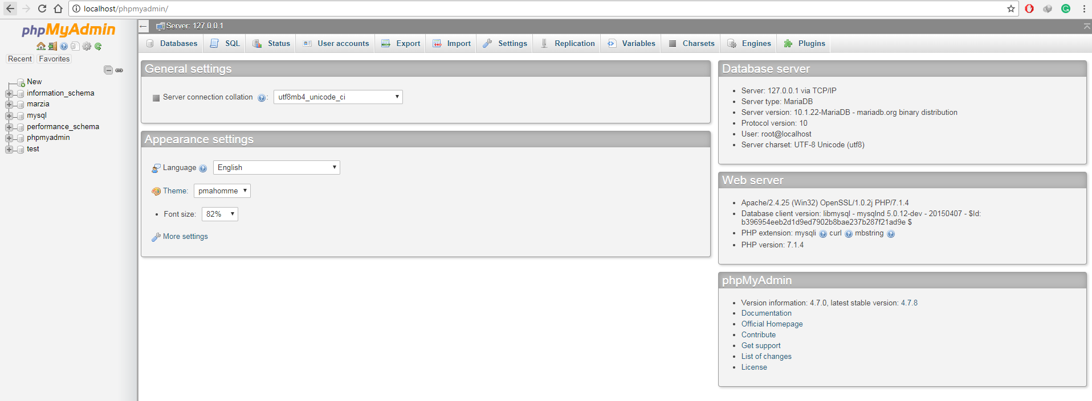

Fig 4: PhpMyAdmin

First of all, install XAMPP for Windows or install LAMPP for Linux.

#### Installing XAMPP for Windows

Go to this link, [**https://www.apachefriends.org/download.html**](https://www.apachefriends.org/download.html), Download the latest version of XAMPP through the Mozilla browser.

After installation, open the XAMPP software and turn on

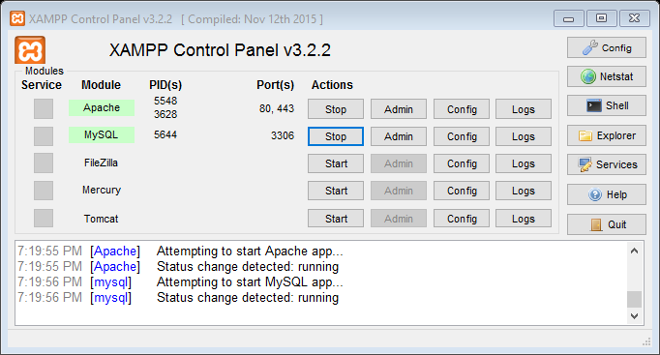

Fig 5: XAMPP Control Panel

Create a folder in **C:\xampp\htdocs\,** you can name folder anything, for the time being let us just create a folder named “practice”. Now we will have **C:\xampp\htdocs\practice,** we can create PHP or HTML files inside it and then deploy it on the browser. Let us create a file, **form.php**. Therefore, we will end up having **C:\xampp\htdocs\practice\form.php.**

Now go to your favorite browser, type [**http://localhost/practice/form.php**](http://localhost/practice/form.php)**,** code in PHP would display here. Therefore **C:\xampp\htdocs\** folder location gets replaced by [**http://localhost/**](http://localhost/) in your browser.

If we type, [**http://localhost/phpmyadmin/**](http://localhost/phpmyadmin/)**,** this will show our MySQL database.

#### Light Weight Editor (Sublime Text Editor)

From this link download, [**https://www.sublimetext.com/3**](https://www.sublimetext.com/3)**,** this is probably one of the best coding editor.

If you want to install packages in sublime text first you need to install **package control.** Press the **Ctrl+`** in sublime editor and copy paste the code given in [**https://packagecontrol.io/installation**](https://packagecontrol.io/installation)**.**

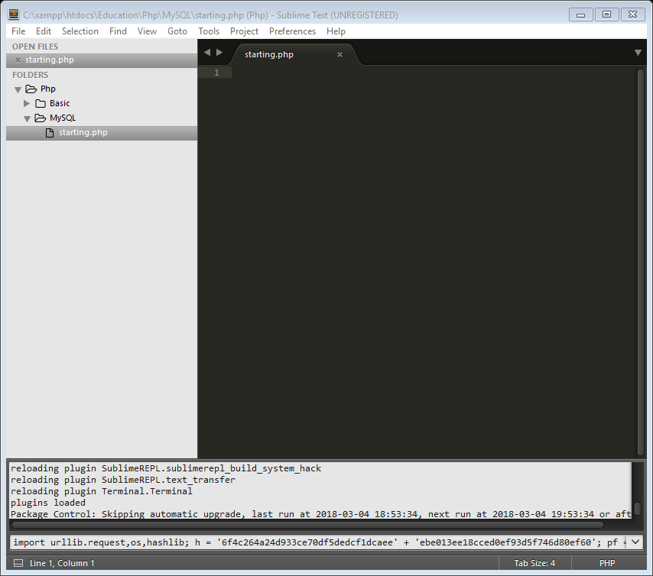

Fig 6: Sublime Text Editor (Package Control Install)

Once installed, press **Ctrl+Shift+P,** type in **Package Control: Install Package**

#### Installing XAMPP for Linux

Go to this link, <https://www.apachefriends.org/download.html>, Download the latest version of XAMPP.

Go to **/Home/Your-Username/Downloads.** Ex: **/Home/Photon/Downloads**

Open the command terminal there and type:

**sudo chmod 777 name-of-the-downloaded-file.**

Ex: **sudo chmod 777 ./xampp-linux-x64-7.2.2-0-installer.run**

This allows the administration permission to install the file

**sudo ./name-of-the-file**

Ex: **./xampp-linux-x64-7.2.2-0-installer.run**

This is how the installation of the file works

**sudo /opt/lamp/lampp start**

This starts the LAMPP on

#### Installing Sublime Editor for Linux

sudo apt-get-repository ppa:webupd8team/sublime-text-3

sudo apt-get update

sudo apt-get install sublime-text-installer

This is how the installation of the file works

### Creating a Database

Creating a database (form_table). Tables are stored in database

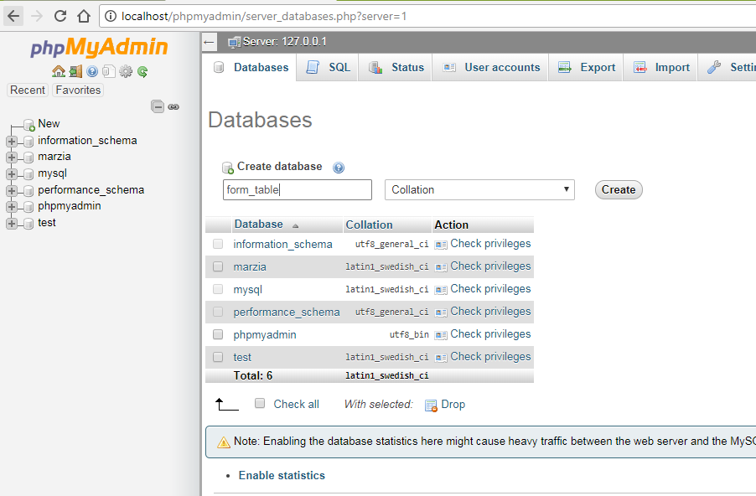

Fig 7: Creating a Database (form_table)

Click on New 🡪 Type in database name (form_table) 🡪 click on create

#### Creating a Table

Tables serves as a way to divide up the data in a database into related groups

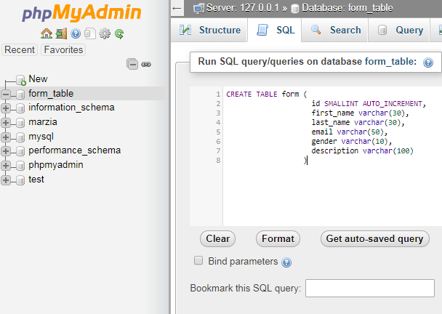

Fig 8: Creating a Table (Inside the form_table Database)

#### Breakdown (SQL: form)

CREATE TABLE form (

id INT AUTO_INCREMENT,

first_name VARCHAR(30),

last_name VARCHAR(30),

email VARCHAR(50),

gender VARCHAR(10),

description VARCHAR(100),

PRIMARY KEY(id)

)

Code 8: Create a form table

CREATE TABLE form

Name of the table is form

id INT AUTO_INCREMENT

Number the rows using id, (integer and it will increment by itself)

first_name VARCHAR(30)

First name will be stored here, its variable character length is 30

email VARCHAR(50)

Variable character length is 50

PRIMARY KEY(id)

This allows id to uniquely identify each record in the table

#### Using INSERT command

INSERT INTO form(first_name, last_name, email, gender, description)

VALUES('Photon', 'Khan', 'khan.photon@gmail.com', 'male', 'I am too fat')

Code 9: Insert data into the form table

INSERT INTO table_name (column_name, …. …. ….. ….)

VALUES (‘value 1’, ‘value 2’)

See the values are in single quotation. Values in the set of parentheses have to be in the same order as the database column names

#### Using SELECT command

SELECT columns FROM table_name

Ex: SELECT first_name, last_name FROM form

SELECT * FROM table_name

Ex: SELECT * FROM form

*: Fetch all the data from all the columns in the table

Code 10: Select data from the table

### Automating SQL using PHP

Using PHP all the data entered through the form will be saved into the database.

<?php

**echo** '<!doctype html>';

**echo** ' <html>';

**echo** ' <head>';

**echo** ' <meta charset = "UTF-8"/>';

**echo** ' <title> Simple Form </title>';

**echo** ' </head>';

**echo** ' <body>';

**echo** ' <p> Please fill out the form </p>';

**echo** ' <form method = "post" action = "';

**echo** $_SERVER['PHP_SELF']."**\"**>";

**echo** ' <label for = "firstname"> First Name: </label>';

**echo** ' <input type = "text" id = "filename" name = "firstname"/><br/>';

**echo** ' <label for = "lastname"> Last Name: </label>';

**echo** ' <input type = "text" id = "lastname" name = "lastname"/><br/>';

**echo** ' <label for = "email"> Email: </label>';

**echo** ' <input type = "email" id = "email" name = "email"/><br/>';

**echo** ' <label for = "gender">Gender: </label>';

**echo** ' Male <input type = "radio" id ="gender" name = "gender" value = "male">';

**echo** ' Female <input type = "radio" id = "gender" name = "gender" value = "female"><br/>';

**echo** ' <label for = "description"> Description: </label>';

**echo** ' <textarea name = "description"> Max word 500 words </textarea><br/>';

**echo** ' <input type = "submit" value = "Submit" name = "submit"/>';

**echo** ' </form>';

**echo** ' </body>';

**echo** ' </html>';

?>

Code 11: Form.php (First Part)

<?php

**if**(!**empty**($_POST["submit"])):

$firstname = $_POST["firstname"];

$lastname = $_POST["lastname"];

$email = $_POST["email"];

$gender = $_POST["gender"];

$description = $_POST["description"];

**echo** "First Name: ".$firstname."<br/>";

**echo** "Last Name: ".$lastname."<br/>";

**echo** "Email: ".$email."<br/>";

**echo** "Gender: ".$gender."<br/>";

**echo** "Description: ".$description."<br/>";

$server_name = "localhost";

$user_name = "root";

$password = "";

$database_name = "form_table";

$connection = mysqli_connect($server_name, $user_name, $password, $database_name)

**or** **die**("Could not connect to the server");

$query = "INSERT INTO form(first_name, last_name, email, gender, description)

VALUES('**$firstname**','**$lastname**', '**$email**', '**$gender**', '**$description**')";

$result = mysqli_query($connection, $query) **or** **die**("Error Querying database");

mysqli_close($connection);

**endif**;

?>

Code 12: Form.php (Second Part)

#### Breakdown (Form.php (Second Part))

$connection = mysqli_connect($server_name, $user_name, $password, $db_name)

**or** **die**("Could not connect to the server");

$query = "INSERT INTO form(first_name, last_name, email, gender, description)

VALUES('**$firstname**','**$lastname**', '**$email**', '**$gender**', '**$description**')";

$result = mysqli_query($connection, $query) **or** **die**("Error Querying database");

mysqli_close($connection);

**endif**;

|  |  |
| --- | --- |
| **Terms** | **Explanation** |
| Mysqli | “i” over here stands for improved |
| mysqli_connect | This allows us to connect to the database |
| $server_name | It is “localhost” by default if we are running website “locally” |
| $user_name | “root”, by default phpMyAdmin gives username as root |
| $password | “”, by default, there is no password |
| $db_name | Database name |
| mysqli_query() | It allows us to send the SQL command using PHP |
| mysqli_close() | Connection should be closed or else the DB might get corrupted |
| **die**() | This function terminates a PHP script and gives the feedback of the error |

To be sure check your phpMyAdmin home page

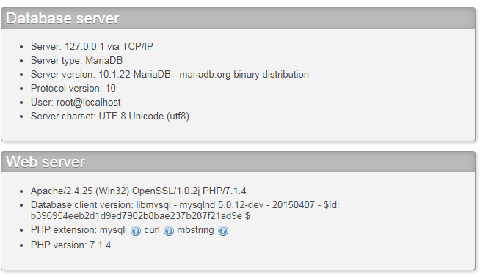

Fig 9: Checking the server name, user name and the password

#### Database check in actual website

First go to **your-name-of-the-website/cpanel**

Ex: [**www.sphotonkhan/cpanel**](http://www.sphotonkhan/cpanel)

Before going to phpMyAdmin, go to MySQL® Database Wizard

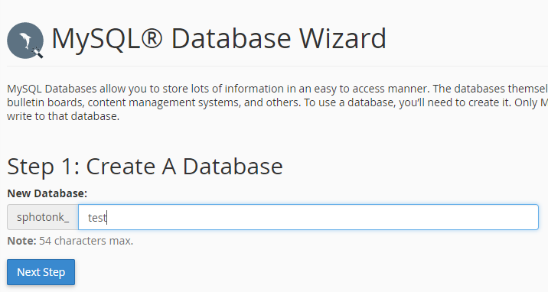

Fig 10: MySQL Database Wizard (1st Step)

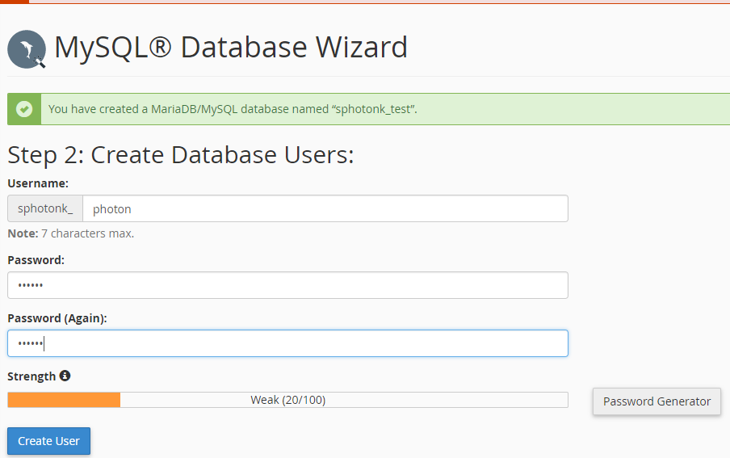

Fig 11: MySQL Database Wizard (2st Step)

|  |  |
| --- | --- |
| $server_name | bh-40 |
| $user_name | sphotonkhan |
| $password | photon |
| $db_name | sphotonk_test |

To get the server information go to Server Information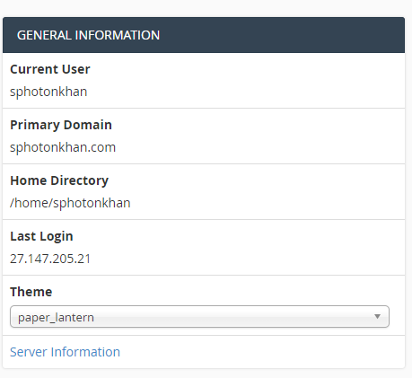

Fig 12: General Information 🡪 Server Information

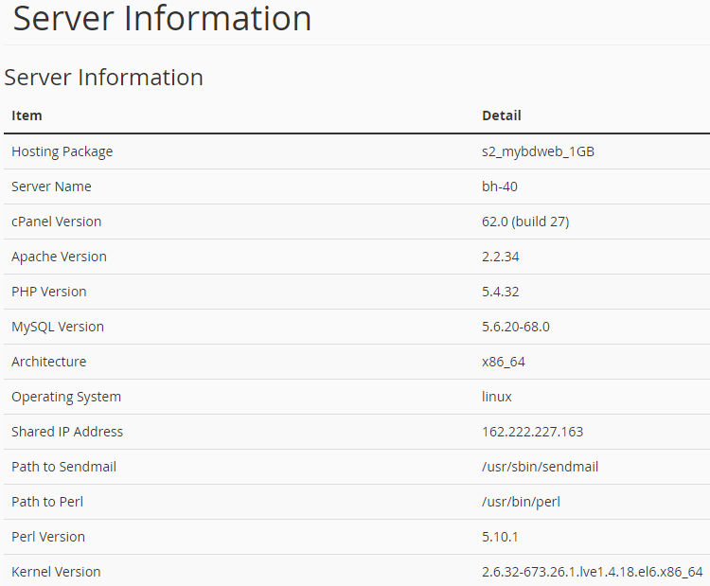

Fig 13: Server Information

#### Selecting all the data from the table

<?php

$server_name = "localhost";

$user_name = "root";

$password = "";

$db_name = "form_table";

$connection = mysqli_connect($server_name, $user_name, $password, $db_name)

**or** **die**("Could not connect to the database");

$query = "SELECT * FROM form";

$result = mysqli_query($connection, $query)

**or** **die**("Query not working");

**while**($row = mysqli_fetch_array($result)){

$id = $row['id'];

$first_name = $row['first_name'];

$last_name = $row['last_name'];

$email = $row['email'];

$gender = $row['gender'];

$description = $row['description'];

**echo** nl2br("Name: **$first_name** **$last_name\n**");

**echo** nl2br("Email: **$email\n**");

**echo** nl2br("Gender: **$gender\n**");

**echo** nl2br("Description: **$gender\n\n**");

}

mysqli_close($connection);

?>

Code 13: Select.php

### Web Application

A web application is a dynamic web site that designed to fulfill a particular purpose for it users.

A database is a container storing data in a very structured way. Table stores data in a grid-like pattern of columns and rows. Columns consists of specific type of data. Rows are collection of columns where a single row consists one of each column. Table rows are horizontal, and table columns are vertical.

**Application Purpose**: Customer wants to add into the newsletter program for a particular shop, i.e. get emails about the discounts and so on. Customer also have the authority to get removed from the newsletter program.

    

Add Email PHP Script PHP Engine Server Database

    

Send Email PHP Script PHP Engine Server Client



Database

Fig 14: Web Application

CREATE DATABASE is the SQL command used to create a new database.

CREATE DATABASE database_name

Ex: CREATE DATABASE store

Text data takes more room to store than integer data. To create a table, we need to know what type of data is stored in each table column.

**Column Types**

CHAR: Character, Highly efficient for the texts with fixed length

INT: Integer, Whole Number, Negative numbers can also be stored

TINYINT: Small Integer

BLOB: Large gobs of binary data

DEC: Decimal

DATETIME: She keeps track of the date

TIMESTAMP: She keeps track of the date

DATE: Keep track of dates

VARCHAR: Variable Character

TEXT: Store huge amount of text

CREATE TABLE SQL is used to create a new table in a database.

CREATE TABLE table_name (column name column type, …)

It is not possible to recreate the same table using CREATE TABLE

USE command selects a database as the default database for subsequent SQL statements

Ex: USE store

DESCRIBE reveals the structure of tables

Ex: DESCRIBE store

DROP deletes a table and all its data from the database

Ex: DROP TABLE store

### Add Email Script

First Create Table

CREATE TABLE email_list(

id INT AUTO_INCREMENT,

first_name VARCHAR(250),

last_name VARCHaR(250),

email VARCHAR(60),

PRIMARY KEY(id)

)

<!doctype html>

<**html**>

<**head**>

<**title**> Add Email </**title**>

<**meta** charset = "UTF-8"/>

</**head**>

<**body**>

<**p**> Enter Your Details </**p**>

<**form** method = "post" action = "addemail.php">

<**label** for = "first_name"> First Name: </**label**>

<**input** type = "text" name = "first_name" id = "first_name"><**br**/>

<**label** for = "last_name"> Last Name: </**label**>

<**input** type = "text" name = "last_name" id = "last_name"><**br**/>

<**label** for = "email"> Email: </**label**>

<**input** type = "email" name = "email" id = "email"><**br**/>

<**input** type = "submit" name = "submit" value = "Submit"/>

</**form**>

</**body**>

</**html**>

Code 14: addemail.html

<?php

$server_name = "localhost";

$user_name = "root";

$password = "";

$db_name = "store";

**if**(!**empty**($_POST['submit'])):

$connection = mysqli_connect($server_name,

$user_name,

$password, $db_name)

**or** **die**("Could not connect to the server");

$first_name = $_POST['first_name'];

$last_name = $_POST['last_name'];

$email = $_POST['email'];

$sql = "INSERT INTO email_list(first_name,

last_name,

email)

VALUES('**$first_name**','**$last_name**','**$email**')";

$result = mysqli_query($connection, $sql)

**or** **die**("Query Denied");

**echo** nl2br("<h1>Confirmation Message</h1> **\n**");

**echo** nl2br("<p>Name: **$first_name** **$last_name**</p>");

**echo** nl2br("<p>Email: **$email**</p> **\n**");

mysqli_close($connection);

**endif**;

?>

Code 15: addemail.php

<!doctype html>

<**htmL**>

<**head**>

<**title**> Send Email </**title**>

<**meta** charset = "UTF-8"/>

</**head**>

<**body**>

<**form** method = "post" action = "sendemail.php">

<**label** for = "subject">Subject</**label**><**br**/>

<**input** type = "text" name = "subject" id = "subject"/><**br**/>

<**label** for = "body_of_email"> Body of Email </**label**><**br**/>

<**textarea** name = "body_of_email" id = "body_of_email"

rows = "8" cols = "60"></**textarea**><**br**/>

<**input** type = "submit" id = "submit" name = "submit"

value = "Submit"/>

</**body**>

</**htmL**>

Code 16: sendemail.html

<?php

**if**(!empty($_POST['submit'])):

$from = "khan.photon@gmail.com";

$subject = $_POST['subject'];

$body_of_email = $_POST['body_of_email'];

$server_name = "localhost";

$user_name = "root";

$password = "";

$db_name = "store";

$connection = mysqli_connect($server_name,

$user_name,

$password,

$db_name)

**or** **die**("Could connect to the server");

$query = "SELECT * FROM email_list";

$result = mysqli_query($connection, $query)

**or** **die**("Query Denied");

**while**($row = mysqli_fetch_array($result)){

$to = $row['email'];

mail($to, $subject, $body_of_email, "From: **$from**");

}

mysqli_close($connection);

**endif**;

?>

Code 17: sendemail.php

mysqli_fetch_array($result)

This function stores a row of data in an array.

A while loop repeats code while a condition is met. $row is interpreted as true since it isn’t set to 0 or false. When there is no more data available, mysqli_fetch_array($result) return false. Anything other than 0 or False is always interpreted as true.

### Removing data using DELETE and WHERE

A where clause narrows down a query to focus on specific rows of data. A where clause in a DELETE statement let us pinpoint the row we want to remove.

DELETE FROM email_list

WHERE email = “khan.photon@gmail.com”

email = Name of the table column

[khan.photon@gmail.com](mailto:khan.photon@gmail.com) = Check whether this exists in the database.

<!doctype html>

<**html**>

<**head**>

<**title**> Remove Email </**title**>

<**meta** charset = "UTF-8"/>

</**head**>

<**body**>

<**p**> Enter Email Address to Remove </**p**><**br**/>

<**form** method = "post" action = "removeemail.php">

<**label** for = "email">Email</**label**><**br**/>

<**input** type = "email" name = "email" id = "email"/><**br**/>

<**input** type = "submit" value = "Submit" name = "submit"/>

</**form**>

</**body**>

<**html**>

Code 18: removeemail.html

<?php

$server_name = "localhost";

$user_name = "root";

$password = "";

$db_name = "store";

**if**(!**empty**($_POST)):

$email = $_POST['email'];

$connection = mysqli_connect($server_name,

$user_name,

$password,

$db_name)

**or** **die**("Could not connect to the server");

$query = "DELETE FROM email_list where email = '**$email**'";

mysqli_query($connection, $query) **or**

**die**("Query Denied");

**echo** nl2br("**$email** has been successfully removed**\n**");

mysqli_close($connection);

**endif**;

?>

Code 19: removeemail.php

### Server-Side Validation

It assures the data we get is the data we expect.

isset(): It tests to see if a variable exists, which means that it’s been assigned a value.

empty(): Determines where the variable contains empty value

PHP defines as 0, an empty string (‘’ or “”), or the values false or NULL

PHP logic operators make it possible to structure more elegant if statements.

Logical AND is coded as && while logical OR is coded as ||

<!doctype html>

<**htmL**>

<**head**>

<**title**> Send Email </**title**>

<**meta** charset = "UTF-8"/>

</**head**>

<**body**>

<**form** method = "post" action = "sendvalidatedemail.php">

<**label** for = "subject">Subject</**label**><**br**/>

<**input** type = "text" name = "subject" id = "subject"/><**br**/>

<**label** for = "body_of_email"> Body of Email </**label**><**br**/>

<**textarea** name = "body_of_email" id = "body_of_email"

rows = "8" cols = "60"></**textarea**><**br**/>

<**input** type = "submit" id = "submit" name = "submit"

value = "Submit"/>

</**body**>

</**htmL**>

Code 20: sendvalidatedemail.html

<?php

**if**(**empty**($_POST['subject']) && !**empty**($_POST['body_of_email'])):

**echo** "Your subject is empty!";

**elseif**(**empty**($_POST['body_of_email']) && !**empty**($_POST['subject'])):

**echo** "Your body of email is empty!";

**elseif**(**empty**($_POST['subject']) && **empty**($_POST['body_of_email'])):

**echo** "Your subject and body of email are empty!";

**elseif**(!empty($_POST['submit']) && !**empty**($_POST['subject']) && !**empty**($_POST['body_of_email'])):

$from = "khan.photon@gmail.com";

$subject = $_POST['subject'];

$body_of_email = $_POST['body_of_email'];

$server_name = "localhost";

$user_name = "root";

$password = "";

$db_name = "store";

$connection = mysqli_connect($server_name,

$user_name,

$password,

$db_name)

**or** **die**("Could connect to the server");

$query = "SELECT * FROM email_list";

$result = mysqli_query($connection, $query)

**or** **die**("Query Denied");

**while**($row = mysqli_fetch_array($result)){

$to = $row['email'];

mail($to, $subject, $body_of_email, "From: **$from**");

}

mysqli_close($connection);

**else**:

**endif**;

?>

Code 21: sendvalidatedemail.php

#### Self-Referencing and Sticky Forms

An HTML form that is part of the PHP script that processes it is known as **self-referencing.**

**Sticky forms** remember the data the user has already correctly entered.

$_SERVER[‘PHP_SELF’] stores away the name of the current script

<?php

$error = [];

$error['sub'] = "";

$error['body'] = "";

**if**(**empty**($_POST['subject']) && !**empty**($_POST['body_of_email'])):

$error['sub'] = "Your subject is empty!";

**endif**;

**if**(**empty**($_POST['body_of_email']) && !**empty**($_POST['subject'])):

$error['body'] = "Your body of email is empty!";

**endif**;

**if**(**empty**($_POST['subject']) && **empty**($_POST['body_of_email'])):

$error['sub'] = "Your subject is empty!";

$error['body'] = "Your body of email is empty!";

**endif**;

**if**(!**empty**($_POST['submit']) && !**empty**($_POST['subject']) && !**empty**($_POST['body_of_email'])):

$from = "khan.photon@gmail.com";

$subject = $_POST['subject'];

$body_of_email = $_POST['body_of_email'];

$server_name = "localhost";

$user_name = "root";

$password = "";

$db_name = "store";

$connection = mysqli_connect($server_name,

$user_name,

$password,

$db_name)

**or** **die**("Could connect to the server");

$query = "SELECT * FROM email_list";

$result = mysqli_query($connection, $query)

**or** **die**("Query Denied");

**while**($row = mysqli_fetch_array($result)){

$to = $row['email'];

mail($to, $subject, $body_of_email, "From: **$from**");

**echo** "Your email has been successfully sent";

}

mysqli_close($connection);

**endif**;

?>

<!doctype html>

<htmL>

<head>

<title> Send Email </title>

<meta charset = "UTF-8"/>

</head>

<body>

<form method = "post" action = "<?php **echo** $_SERVER['PHP_SELF'];?>">

<label for = "subject">Subject</label><br/>

<input type = "text" name = "subject" id = "subject"

value = "<?php **if**(!**empty**($_POST['subject'])) **echo** $_POST['subject']; ?>"/>

<?php **if**($error['sub'] && !**empty**($_POST['submit'])) **echo** $error['sub'];?><br/>

<label for = "body_of_email"> Body of Email </label><br/>

<textarea name = "body_of_email" id = "body_of_email"

rows = "8" cols = "60"><?php **if**(!**empty**($_POST['body_of_email'])) **echo** $_POST['body_of_email'];?></textarea>

<?php **if**($error['body'] && !**empty**($_POST['submit'])) **echo** $error['body'];?><br/>

<input type = "submit" id = "submit" name = "submit"

value = "Submit"/>

</body>

</htmL>

Code 22: sendemailupdated.php

### Avoid duplicate entry in Database

Table rows should be **uniquely identifiable.** Therefore, we will create a unique integer column, also called a **primary key**

To alter the table that already exists

ALTER TABLE table_name ADD column_name, column_type

Location: first in the table

ALTER TABLE email_list ADD id INT NOT NULL AUTO_INCREMENT FIRST, ADD PRIMARY KEY(id)

Column that we want to add Increase the value of id by 1 automatically id is the primary key

A primary key is a column in our table that makes each row unique

<!doctype html>

<html>

<head>

<title> Remove Email </title>

<meta charset = "UTF-8"/>

</head>

<body>

<p> Delete Email Addresses </p>

<?php

$showform = **TRUE**;

$server_name = "localhost";

$user_name = "root";

$password = "";

$db_name = "store";

$connection = mysqli_connect($server_name,

$user_name,

$password,

$db_name)

**or** **die**("Could not connect to the server");

**if**(isset($_POST['submit'])):

$email = $_POST['email'];

$showform = **FALSE**;

$query = "SELECT * FROM email_list WHERE email = '**$email**'";

$result = mysqli_query($connection, $query) **or**

**die**("Select Query Denied");

**echo** "<form method = 'post' action = '".$_SERVER['PHP_SELF']."'>";

**while**($row = mysqli_fetch_array($result)){

$id = $row['id'];

$name = $row['first_name']." ".$row['last_name'];

$email = $row['email'];

**echo** "<input type = 'checkbox' value = **\"$id\**" name = \"todelete[] **\"**/>";

**echo** "**$name** **$email**<br/>";

}

**echo** "<br/><input type = 'submit' value = 'Remove' name = 'remove'/>";

**echo** "</form>";

**endif**;

**if**(isset($_POST['remove'])):

$showform = **FALSE**;

**foreach**($_POST['todelete'] **as** $delete_id){

$query = "DELETE FROM email_list where id = '**$delete_id**'";

mysqli_query($connection, $query) **or** **die** ("Remove Query Denied");

}

**echo** "Customers Removed Successfully";

**endif**;

?>

<?php

**if**($showform):

?>

<form method = "post" action = "<?php **echo** $_SERVER['PHP_SELF'];?>">

<label for = "email">Email</label><br/>

<input type = "email" name = "email" id = "email"/><br/>

<input type = "submit" value = "Submit" name = "submit"/>

</form>

</body>

<html>

<?php

**endif**;

?>

Code 23: removeemailupdated.php

### Inventory (ALTER TABLE)

Making a web application related to a shop

|  |  |  |  |  |
| --- | --- | --- | --- | --- |
| **ID** | **Date Added** | **Product** | **Price** | **Image** |
| 1 | 2007-04-22 14:37:34 | Lip stick | 25.00 | --- |
| 2 | 2009-01-12 21:27:54 | Chocolate | 5.23 | --- |
| 3 | 2011-12-23 09:06:35 | Shampoo | 40.15 | --- |
| 4 | 2013-08-04 09:12:53 | Shoe | 150.14 | --- |
| 5 | 2012-02-21 14:09:50 | Soap | 9.19 | --- |

The Alter statement is used to change the structure of a database

ALTER TABLE inventory ADD COLUMN age TINYINT

Add a column to a table

ALTER TABLE inventory CHANGE COLUMN image screenshot VARCHAR(255)

Change the name and data type of the column

ALTER TABLE inventory DROP COLUMN age

Drops the column

ALTER TABLE inventory MODIFY COLUMN date DATETIME AFTER age

Only First & AFTER can be used to alter the position

Changes the data type or position of a column within a table

### Uploading a File

<form enctype = "multipart/form=data" method = "post"

action = "<?php echo **$_SERVER['PHP_SELF']**;?>">

enctype attribute tells the form to use a special type of encoding required for the upload – it affects how the POST data is bundled and sent when the form is submitted

<input type = "hidden" name = "MAX_FILE_SIZE" value = "32768"/>

Establishes the maximum file size for file uploads in this case, 32 KB (32,768)

INSERT INTO inventory VALUES(NOW(), ‘$name’, ‘$price’, ‘$image’)

NOW() function is used to insert the current date/time.

Image filenames are stored in the database as part of an INSERT statement

$_FILES

It is a built-in super global variable provides access to information about uploaded files.

$_FILES[‘image’][‘name’]

The name of the uploaded file

$_FILES[‘image’][‘type’]

MIME type of the uploaded file

$_FILES[‘image’][‘tmp_name’]

Temporary storage location of the file on the server

$_FILES[‘error’][‘error’]

The error code for the file upload, 0 indicates a success, other values indicate failure

move_uploaded_file($_FILES[‘image’][‘tmp_name’], $target)

Placing an image on a web page only requires reference to the image file.

The file that is being uploaded actually stores in a temporary folder on the server. Temporary folder after a certain time deletes the file. Therefore. to save the file, we need to use move_uploaded_file() function to move the file from temporary to the current directory.

UPLOAD_PATH = “images/”

It is a constant, it values stays the same

Define a constant using define(‘UPLOAD_PATH’, ‘/images’)

$target = UPLOAD_PATH.$FILES[‘image’][‘name]

Therefore, the target location is “images/name-of-the-file.png”

<!doctype html>

<html>

<head>

<title> Inventory Index </title>

<meta charset = "UTF-8"/>

</head>

<body>

<h1> Inventory **List** </h1>

<p><a href = "addinventory.php">Add Item</a></p>

<p> **List** of items are given below</p>

<?php

$server_name = "localhost";

$user_name = "root";

$password = "";

$db_name = "store";

define("UPLOAD_PATH","images/");

$connection = mysqli_connect($server_name, $user_name,

$password, $db_name)

**or** **die**("Could not conenct to the database");

$query = "SELECT * FROM inventory";

$result = mysqli_query($connection, $query);

**echo** "<table>";

**echo** "<tr>";

**echo** "<th>Date</th>";

**echo** "<th>Name</th>";

**echo** "<th>Price</th>";

**echo** "<th>Image</th>";

**echo** "</tr>";

**while**($row = mysqli_fetch_array($result)){

**echo** "<tr>";

**echo** "<td>".$row['date']."</td>";

**echo** "<td>".$row['name']."</td>";

**echo** "<td>".$row['price']."</td>";

**echo** "<td><img src ='".UPLOAD_PATH.$row['image']."' alt = 'Inventory Image'

height = '20px' width = '20px'/></td>";

**echo** "</tr>";

}

**echo** "</table>";

?>

</body>

</html>

Code 24: inventoryindex.php

<?php

$show_form = **TRUE**;

define("UPLOAD_PATH","images/");

$server_name = "localhost";

$user_name = "root";

$password = "";

$db_name = "store";

$connection = mysqli_connect($server_name, $user_name, $password, $db_name)

**or** **die**("Server Connection Denied");

**if**(isset($_POST['submit'])):

$name = $_POST['item_name'];

$price = $_POST['price'];

$image_name = $_FILES['image']['name'];

**if**(!**empty**($name) && !**empty**($price) && !**empty**($image_name)):

$show_form = **FALSE**;

$target = UPLOAD_PATH.$image_name;

*// $date = date("Y-m-d h:i:s");*

$query = "INSERT INTO inventory VALUES(0, NOW(), '**$name**', '**$price**', '**$image_name**')";

mysqli_query($connection, $query) **or** **die**("Query Denied");

move_uploaded_file($_FILES['image']['tmp_name'], $target);

**echo** "Inventory Added Successfully";

**endif**;

**endif**;

?>

<?php

**if**($show_form):

?>

<!doctype html>

<html>

<head>

<title> Add Inventory </title>

<meta charset = "UTF-8"/>

</head>

<body>

<p> Add Inventory </p>

<form enctype = "multipart/form-data" method = "post"

action = "<?php **echo** $_SERVER['PHP_SELF'];?>">

<!-- <input type = "hidden" name = "MAX_FILE_SIZE" value = "32768"/> -->

<label for = "item_name"> Item Name: </label><br/>

<input type = "text" name = "item_name" id = "item_name"/><br/>

<label for = "price"> Price: </label><br/>

<input type = "number" name = "price" id = "price" step = "0.01"/><br/>

<input type = "file" name = "image" id = "image"/><br/><br/>

<input type = "submit" value = "Add Item" name = "submit"/>

</body>

</html>

<?php

**endif**;

?>

Code 25: addinventory.php

#### Check File or not

<?php

$file_path = "images/chips.png";

**if**(is_file($file_path) && filesize($file_path)):

**echo** "It is a file";

**endif**;

?>

Code 26: checkfile.php

Databases are great for storing text data, but it’s normally better for them to reference binary data in external files.

### Sharing Data

Shared script data needs to be accessible throughout an application without code duplication. Include files allows us to share code across multiple scripts

require_once, the name “include file” comes from a PHP statement called include that is very similar to require_once. The difference is that require_once results in an error if the included file cannot be found. “include” won’t reveal an error if an include file is missing. There are in total four of them: include, include_once, require, require_once.

Therefore, **require** and **require_once,** will shot **fatal error** if the file is missing

Therefore, **include** and **include_once**, will show warning and continue load the rest of the page.

Therefore, difference between **include** and **include_once**, if the code from a file has been already included then it will not be included again if we use **include_once()**. Means **include_once()** include the file only once at a time. Same for **require** and **require_once.**

require_once statement inserts shared script code into other scripts.

Let’s reorganize the previous files

<?php

define("UPLOAD_PATH","images/");

$server_name = "localhost";

$user_name = "root";

$password = "";

$db_name = "store";

?>

Code 27: databaseinfo.php

<!doctype html>

<html>

<head>

<title> Inventory Index </title>

<meta charset = "UTF-8"/>

</head>

<body>

<h1> Inventory **List** </h1>

<p><a href = "addinventory.php">Add Item</a></p>

<p> **List** of items are given below</p>

<?php

**require_once**("common/databaseinfo.php");

$connection = mysqli_connect($server_name, $user_name,

$password, $db_name)

**or** **die**("Could not conenct to the database");

$query = "SELECT * FROM inventory";

$result = mysqli_query($connection, $query);

**echo** "<table>";

**echo** "<tr>";

**echo** "<th>Date</th>";

**echo** "<th>Name</th>";

**echo** "<th>Price</th>";

**echo** "<th>Image</th>";

**echo** "</tr>";

**while**($row = mysqli_fetch_array($result)){

**echo** "<tr>";

**echo** "<td>".$row['date']."</td>";

**echo** "<td>".$row['name']."</td>";

**echo** "<td>".$row['price']."</td>";

**echo** "<td><img src ='".UPLOAD_PATH.$row['image']."' alt = 'Inventory Image'

height = '20px' width = '20px'/></td>";

**echo** "</tr>";

}

**echo** "</table>";

?>

</body>

</html>

Code 28: updatedinventoryindex.php

<?php

**require_once**("common/databaseinfo.php");

$show_form = **TRUE**;

$connection = mysqli_connect($server_name, $user_name, $password, $db_name)

**or** **die**("Server Connection Denied");

**if**(isset($_POST['submit'])):

$name = $_POST['item_name'];

$price = $_POST['price'];

$image_name = $_FILES['image']['name'];

**if**(!**empty**($name) && !**empty**($price) && !**empty**($image_name)):

$show_form = **FALSE**;

$target = UPLOAD_PATH.$image_name;

*// $date = date("Y-m-d h:i:s");*

$query = "INSERT INTO inventory VALUES(0, NOW(), '**$name**', '**$price**', '**$image_name**')";

mysqli_query($connection, $query) **or** **die**("Query Denied");

move_uploaded_file($_FILES['image']['tmp_name'], $target);

**echo** "Inventory Added Successfully";

**endif**;

**endif**;

?>

<?php

**if**($show_form):

?>

<!doctype html>

<html>

<head>

<title> Add Inventory </title>

<meta charset = "UTF-8"/>

</head>

<body>

<p> Add Inventory </p>

<form enctype = "multipart/form-data" method = "post"

action = "<?php **echo** $_SERVER['PHP_SELF'];?>">

<!-- <input type = "hidden" name = "MAX_FILE_SIZE" value = "32768"/> -->

<label for = "item_name"> Item Name: </label><br/>

<input type = "text" name = "item_name" id = "item_name"/><br/>

<label for = "price"> Price: </label><br/>

<input type = "number" name = "price" id = "price" step = "0.01"/><br/>

<input type = "file" name = "image" id = "image"/><br/><br/>

<input type = "submit" value = "Add Item" name = "submit"/>

</body>

</html>

<?php

**endif**;

?>

Code 29: updatedinventoryadd.php

### Order the table data

SELECT * FROM inventory ORDER BY ASC, price DESC;

<!doctype html>

<htmL>

<head>

<title> Order Inventory </title>

<meta charset = "UTF-8"/>

</head>

<body>

<?php

**require_once**("common/databaseinfo.php");

$connection = mysqli_connect($server_name, $user_name,

$password, $db_name)

**or** **die**("Could not conenct to the database");

$query = "SELECT * FROM inventory ORDER BY price DESC";

$result = mysqli_query($connection, $query);

**echo** "<table>";

**echo** "<tr>";

**echo** "<th>Date</th>";

**echo** "<th>Name</th>";

**echo** "<th>Price</th>";

**echo** "<th>Image</th>";

**echo** "</tr>";

$i = 0;

**while**($row = mysqli_fetch_array($result)){

**if**($i == 0):

**echo** "<p>Most Expensive Product: ".$row['name']."</p>";

**echo** "<p>Price: ".$row['price']."</p>";

**echo** "<p>Date Added: ".$row['date']."</p>";

**endif**;

**echo** "<tr>";

**echo** "<td>".$row['date']."</td>";

**echo** "<td>".$row['name']."</td>";

**echo** "<td>".$row['price']."</td>";

**echo** "<td><img src ='".UPLOAD_PATH.$row['image']."' alt = 'Inventory Image'

height = '20px' width = '20px'/></td>";

**echo** "</tr>";

$i++;

}

**echo** "</table>";

?>

</body>

</htmL>

Code 30: orderinventory.php

### File Validation

$_FILES[‘image’][‘size’]

It gives the information about the file size

$_FILES[‘image’][‘size’]

It gives the information about the file type

unlink() + @ = @unlink

It deletes a file from the web server. We can suppress error reporting with @ in case the file upload didn’t actually happen.

<?php

**require_once**("common/databaseinfo.php");

$show_form = **TRUE**;

$connection = mysqli_connect($server_name, $user_name, $password, $db_name)

**or** **die**("Server Connection Denied");

**if**(isset($_POST['submit'])):

$name = $_POST['item_name'];

$price = $_POST['price'];

$image_name = $_FILES['image']['name'];

$type = $_FILES['image']['type'];

$size = $_FILES['image']['size'];

$error = $_FILES['image']['error'];

**if**(!**empty**($name) && !**empty**($price) && !**empty**($image_name)):

**if**( ($type == "image/gif")

|| ($type == "image/jpeg")

|| ($type == "image/png")

|| ($type == "image/pjpeg") && ($size > 0) && $error == 0):

$show_form = **FALSE**;

$target = UPLOAD_PATH.$image_name;

*// $date = date("Y-m-d h:i:s");*

$query = "INSERT INTO inventory VALUES(0, NOW(), '**$name**', '**$price**', '**$image_name**')";

mysqli_query($connection, $query) **or** **die**("Query Denied");

move_uploaded_file($_FILES['image']['tmp_name'], $target);

**echo** "Inventory Added Successfully";

**endif**;

**endif**;

@unlink($_FILES['image']['tmp_name']);

**endif**;

?>

<?php

**if**($show_form):

?>

<!doctype html>

<html>

<head>

<title> Add Inventory </title>

<meta charset = "UTF-8"/>

</head>

<body>

<p> Add Inventory </p>

<form enctype = "multipart/form-data" method = "post"

action = "<?php **echo** $_SERVER['PHP_SELF'];?>">

<!-- <input type = "hidden" name = "MAX_FILE_SIZE" value = "32768"/> -->

<label for = "item_name"> Item Name: </label><br/>

<input type = "text" name = "item_name" id = "item_name"/><br/>

<label for = "price"> Price: </label><br/>

<input type = "number" name = "price" id = "price" step = "0.01"/><br/>

<input type = "file" name = "image" id = "image"/><br/><br/>

<input type = "submit" value = "Add Item" name = "submit"/>

</body>

</html>

<?php

**endif**;

?>

Code 31: filevalidation.php

### Admin Page

Web applications often include pages for public access, as well as admin pages that are only for site maintenance. The two types of web requests, GET and POST, control how we shuttle data between scripts.

#### Post and Get Requests

|  |  |
| --- | --- |
| **POST** | **GET** |
| It sends data to the server, after which the state of server usually changes in response to the data sent | Primarily to retrieve data from the server without affecting anything on the server |
| Works only in form tag | Works outside the form tag as well |
| POST requests can only be initiated through a form | The url of a script can be used to pass data as a GET request. |
| Data passed are not seen in the url | Data passed are seen in the url |
| INSERT, DELETE, UPDATE, SELECT | SELECT |

#### Limit

DELETE FROM inventory WHERE id = “$id” LIMIT 1

This puts safety, by creating a limit on the number of rows that can be deleted.

### Remove Data Using GET and POST

<?php

**require**("common/databaseinfo.php");

$connection = mysqli_connect($server_name, $user_name, $password, $db_name);

$query = "SELECT * FROM inventory";

$result = mysqli_query($connection, $query);

?>

<!doctype html>

<html>

<head>

<title> Admin Remove Inventory </title>

</head>

<body>

<?php

**echo** "<table>";

**echo** "<tr>";

**echo** "<th>Date</th>";

**echo** "<th>Name</th>";

**echo** "<th>Price</th>";

**echo** "<th>Image</th>";

**echo** "<th>Remove</th>";

**echo** "</tr>";

**while**($row = mysqli_fetch_array($result)){

**echo** "<tr>";

**echo** "<td>".$row['date']."</td>";

**echo** "<td>".$row['name']."</td>";

**echo** "<td>".$row['price']."</td>";

**echo** "<td><img src ='".UPLOAD_PATH.$row['image']."' alt = 'Inventory Image'

height = '20px' width = '20px'/></td>";

**echo** "<td><a href = 'adminremoveinventory.php?inventory_id=".$row['inventory_id']

."&amp;date=".$row['date']

."&amp;name=".$row['name']

."&amp;price=".$row['price']

."&amp;image=".$row['image']

."'>Remove</a></td>";

**echo**"</tr>";

}

**echo** "</table>";

mysqli_close($connection);

?>

</form>

</body>

</html>

Code 32: admingetremove.php

<?php

$showconfirmform= **TRUE**;

**require**("common/databaseinfo.php");

**if**($showconfirmform):

**echo** "<!doctype html>";

**echo** " <html>";

**echo** " <head>";

**echo** " <title> Remove Inventory Confirmation </title>";

**echo** " <meta charset = 'UTF-8'/>";

**echo** " </head>";

**echo** " <body>";

$connection = mysqli_connect($server_name, $user_name, $password, $db_name)

**or** **die**("Server Error");

**if**( isset($_GET['inventory_id']) &&

isset($_GET['name']) &&

isset($_GET['price']) &&

isset($_GET['image'])

):

**echo** "<h2> Are you sure? </h2>";

**echo** "<form method = 'post' action = '".$_SERVER['PHP_SELF']."'>";

$inventory_id = $_GET['inventory_id'];

$name = $_GET['name'];

$price = $_GET['price'];

$image = $_GET['image'];

$query = "SELECT * FROM inventory WHERE inventory_id = '**$inventory_id**'";

$result = mysqli_query($connection, $query) **or** **die**("Query Denied");

**while**($row = mysqli_fetch_array($result)){

**echo** "Name: ".$row['name']."<br/>";

**echo** "Price: ".$row['price']."<br/>";

**echo** "<img src = '".UPLOAD_PATH.$row['image']

."' alt = 'Inventory Image'"

."height='30px' width='30px'"

."/><br/>";

**echo** "<input type = 'hidden' name = 'inventory_id' value = '**$inventory_id**'/>";

**echo** "<input type = 'hidden' name = 'image' value = '".UPLOAD_PATH.$row['image']."'/>";

**echo** "Yes<input type = 'radio' name = 'confirmation' value = 'yes'/>";

**echo** "No <input type = 'radio' name = 'confirmation' value = 'no'/><br/>";

**echo** "<input type = 'submit' name = 'submit' value = 'Confirm'/>";

}

**endif**;

**endif**;

?>

</form>

</body>

</html>

<?php

**if**(isset($_POST['submit']) && ($_POST['confirmation'] == "yes")):

$showconfirmform = **FALSE**;

$inventory_id = $_POST['inventory_id'];

$query = "DELETE FROM inventory WHERE inventory_id = '**$inventory_id**'";

mysqli_query($connection, $query) **or** **die**("Query Denied");

@unlink($_POST['image']);

**echo** "Deleted Successfully!";

**endif**;

**if**(isset($_POST['submit']) && ($_POST['confirmation'] == "no")):

$showconfirmform = **FALSE**;

**echo** "<p><a href = 'admingetremove.php'>Home Page</a></p>";

**endif**;

?>

Code 33: adminremoveinventory.php

### Securing Application

HTTP authentication provides a simple way to secure to a page using PHP. HTTP is the hyper -text transfer protocol.

Username: $_SERVER[‘PHP_AUTH_USER’]

Password: $_SERVER[‘PHP_AUTH_PW’]

Browser and servers use headers quite often to communicate outside of the context of PHP, but PHP does allow us to send a header.

All web pages are delivered with the help of headers. HTTP authentication requires headers. Header control precisely how and what kind of information is passed back and forth between a web browser and web server.

#### HTTP Request

Get /index.php HTTP/1

It’s GET request for the page

Host: [www.google.com](http://www.google.com)

Most individual headers consist of a name/value pair separated by a colon

Checking header information using Chrome browser,

User-Agent: Mozilla/4.0…

Header specifies the browser that is doing the requesting

#### HTTP Response

HTTP/1.1 200 OK

Server’s JTTP response

Content-Type: text/html

This header tells the browser that the content is HTML code

Checking the header using the google chrome browser

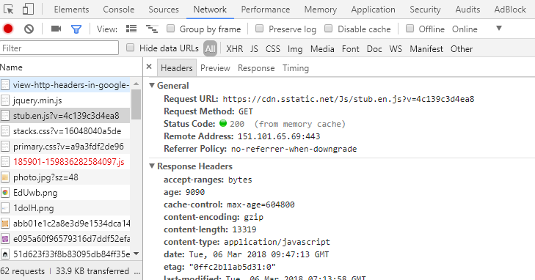

Fig 15: Checking Header (CTRL+SHIFT+I) or F12

#### Headers

The header() function lets you create and send a header from a PHP script

Headers(‘Content-Type: text/html’);

// There should be no space before <?php tag

<?php

Server send this header to the browser for processing before attempting to send any of the HTML content in the page.

**Header(‘Content-Type: text/html’);**

Spaces inside of the <?php ?> tags aren’t a problem because they aren’t passed along to the browser.

?>

Two specific headers are required to request the authentication of a web page.

HTTP/1.1. 401 Unauthorized

This header lets the browser know that the user in not authorized to view the page

WWW-Authenticate: Basic realm=”store”

Basic realm is just a phrase used to uniquely identify this. Particular authentication-it appears in the authentication window.

exit()

An application has an opportunity to exit the script and display a custom denial message.

Headers can be used for other purposes too.

<?php

Header(’Location:http://www.addinventory.php’);

?>

The header is called a location header and redirects the current page to addinventory.php

<?php

Header(’Refresh: 5; url=http://www.addinventory.php’);

?>

This header is called a refresh header since it refreshes a page after a period of time.

<?php

Header(’Content-Type: text-plain’);

?>

Headers must be the very first thing sent to the browser in a PHP file. It is because the headers must be sent before any content, it is extremely important to not allow even a single space to appear outside of PHP code before calling the header() function in a PHP script.

Basic Realm defines a security zone that is protected by a particular username and password. Once the user name and password have been successfully entered for a given realm, the browser will remember it and not continue to display the authentication window for subsequent authentication headers in the same realm. In other words, realms allow a browser to remember that we have met the security requirements of a given collection of pages—just specify the same realm for the authentication headers in the pages.

<?php

$username = "photon";

$password = "khan";

**if**(

!isset($_SERVER['PHP_AUTH_USER']) ||

!isset($_SERVER['PHP_AUTH_PW']) ||

($_SERVER['PHP_AUTH_USER'] != $username) ||

($_SERVER['PHP_AUTH_PW'] != $password)

):

header('HTTP/1.1 401 Unauthorized');

header('WWW-Authenticate: Basic realm="Store"');

**exit**('<h2> You must enter a valid username and password');

**endif**;

?>

Code 34: header.php

#### Human Moderation

Human moderation is an excellent way to improve the integrity of user-submitted content.

Adding approval link beside the remove

ALTER TABLE inventory ADD COLUMN approved TINYINT;

Alternatively, ALTER TABLE inventory ADD COLUMN approved ENUM(‘yes’, ‘no’)

UPDATE inventory SET approved = 1 WHERE inventory_id = '$inventory_id'

Use this to update the data in the table

#### SQL Injection

Tricking MySQL with comments. A double hyphen (--) is used in SQL to comment out the remainder of a line of SQL code. To make it work, it is double hyphen with a space (-- ), everything after it is ignored.

SQL code:

INSERT INTO inventory VALUES(0, NOW(), ‘Hacker’, ‘10000000’, ‘hacker.png’, 1) – hacker.png

1 is used to approve and everything after – is commented.

Form fields are security weak point for web applications because they allow users to enter data.

Dangerous characters are any characters that could possibly change the nature of any SQL-query, such as commas, quotes or – comment characters. Even the spaces at the end of a piece of data can prove harmful. SQL injections can be prevented by properly processing form data.

trim()

Eliminates Leading or trailing spaces

Ex: $name = trim($_POST[‘name’]);

mysqli_real_escape_string($connection, trim($_POST[‘name]));

It converts dangerous characters into an escaped format that won’t adversely affect SQL queries.

The id and approved columns can then be allowed to default to AUTO_INCREMENT and 0, respectively.

<!doctype html>

<html>

<head>

<title> Inventory Index </title>

<meta charset = "UTF-8"/>

</head>

<body>

<h1> Inventory **List** </h1>

<p><a href = "addinventory.php">Add Item</a></p>

<p> **List** of items are given below</p>

<?php

**require_once**("common/databaseinfo.php");

$connection = mysqli_connect($server_name, $user_name,

$password, $db_name)

**or** **die**("Could not conenct to the database");

$query = "SELECT * FROM inventory";

$result = mysqli_query($connection, $query);

**echo** "<table>";

**echo** "<tr>";

**echo** "<th>Date</th>";

**echo** "<th>Name</th>";

**echo** "<th>Price</th>";

**echo** "<th>Image</th>";

**echo** "</tr>";

**while**($row = mysqli_fetch_array($result)){

**echo** "<tr>";

**if**($row['approved'] == 1):

**echo** "<td>".$row['date']."</td>";

**echo** "<td>".$row['name']."</td>";

**echo** "<td>".$row['price']."</td>";

**echo** "<td><img src ='".UPLOAD_PATH.$row['image']."' alt = 'Inventory Image'

height = '20px' width = '20px'/></td>";

**endif**;

**echo** "</tr>";

}

**echo** "</table>";

?>

</body>

</html>

Code 35: inventoryindex.php

<?php

**require_once**("common/databaseinfo.php");

$show_form = **TRUE**;

$connection = mysqli_connect($server_name, $user_name, $password, $db_name)

**or** **die**("Server Connection Denied");

**if**(isset($_POST['submit'])):

$name = mysqli_real_escape_string($connection, trim($_POST['item_name']));

$price = mysqli_real_escape_string($connection, trim($_POST['price']));

$image_name = mysqli_real_escape_string($connection, trim($_FILES['image']['name']));

**if**(!**empty**($name) && !**empty**(is_numeric($price)) && !**empty**($image_name)):

$show_form = **FALSE**;

$target = UPLOAD_PATH.$image_name;

*// $date = date("Y-m-d h:i:s");*

$query = "INSERT INTO inventory(date, name, price, image)

VALUES(NOW(), '**$name**', '**$price**', '**$image_name**')";

mysqli_query($connection, $query) **or** **die**("Query Denied");

move_uploaded_file($_FILES['image']['tmp_name'], $target);

**echo** "Inventory Added Successfully";

**endif**;

**endif**;

?>

<?php

**if**($show_form):

?>

<!doctype html>

<html>

<head>

<title> Add Inventory </title>

<meta charset = "UTF-8"/>

</head>

<body>

<p> Add Inventory </p>

<form enctype = "multipart/form-data" method = "post"

action = "<?php **echo** $_SERVER['PHP_SELF'];?>">

<!-- <input type = "hidden" name = "MAX_FILE_SIZE" value = "32768"/> -->

<label for = "item_name"> Item Name: </label><br/>

<input type = "text" name = "item_name" id = "item_name"/><br/>

<label for = "price"> Price: </label><br/>

<input type = "number" name = "price" id = "price" step = "0.01"/><br/>

<input type = "file" name = "image" id = "image"/><br/><br/>

<input type = "submit" value = "Add Item" name = "submit"/>

</body>

</html>

<?php

**endif**;

?>

Code 36: addinventory.php

<?php **require_once**("common/header.php"); ?>

<?php

**require_once**("common/databaseinfo.php");

$connection = mysqli_connect($server_name, $user_name, $password, $db_name);

$query = "SELECT * FROM inventory";

$result = mysqli_query($connection, $query);

?>

<!doctype html>

<html>

<head>

<title> Admin Remove Inventory </title>

</head>

<body>

<?php

**echo** "<table>";

**echo** "<tr>";

**echo** "<th>Date</th>";

**echo** "<th>Name</th>";

**echo** "<th>Price</th>";

**echo** "<th>Image</th>";

**echo** "<th>Remove</th>";

**echo** "<th>Status</th>";

**echo** "</tr>";

**while**($row = mysqli_fetch_array($result)){

**echo** "<tr>";

**echo** "<td>".$row['date']."</td>";

**echo** "<td>".$row['name']."</td>";

**echo** "<td>".$row['price']."</td>";

**echo** "<td><img src ='".UPLOAD_PATH.$row['image']."' alt = 'Inventory Image'

height = '20px' width = '20px'/></td>";

**echo** "<td><a href = 'adminremoveinventory.php?inventory_id=".$row['inventory_id']

."&amp;date=".$row['date']

."&amp;name=".$row['name']

."&amp;price=".$row['price']

."&amp;image=".$row['image']

."'>Remove</a></td>";

**if**($row['approved'] == 0):

**echo** "<td><a href = 'approve.php?inventory_id=".$row['inventory_id']."'>Approve</a></td>";

**endif**;

**echo**"</tr>";

}

**echo** "</table>";

mysqli_close($connection);

?>

</form>

</body>

</html>

Code 37: admingetremove.php

<?php **require_once**("common/header.php");?>

<?php

$showconfirmform= **TRUE**;

**require**("common/databaseinfo.php");

**if**($showconfirmform):

**echo** "<!doctype html>";

**echo** " <html>";

**echo** " <head>";

**echo** " <title> Approve Inventory </title>";

**echo** " <meta charset = 'UTF-8'/>";

**echo** " </head>";

**echo** " <body>";

$connection = mysqli_connect($server_name, $user_name, $password, $db_name)

**or** **die**("Server Error");

**if**(isset($_GET['inventory_id'])):

**echo** "<h2> Are you sure? </h2>";

**echo** "<form method = 'post' action = '".$_SERVER['PHP_SELF']."'>";

$inventory_id = $_GET['inventory_id'];

$query = "SELECT * FROM inventory WHERE inventory_id = '**$inventory_id**'";

$result = mysqli_query($connection, $query) **or** **die**("Query Denied");

**while**($row = mysqli_fetch_array($result)){

**echo** "Name: ".$row['name']."<br/>";

**echo** "Price: ".$row['price']."<br/>";

**echo** "<img src = '".UPLOAD_PATH.$row['image']

."' alt = 'Inventory Image'"

."height='30px' width='30px'"

."/><br/>";

**echo** "<input type = 'hidden' name = 'inventory_id' value = '**$inventory_id**'/>";

**echo** "<input type = 'hidden' name = 'image' value = '".UPLOAD_PATH.$row['image']."'/>";

**echo** "Yes<input type = 'radio' name = 'confirmation' value = 'yes'/>";

**echo** "No <input type = 'radio' name = 'confirmation' value = 'no'/><br/>";

**echo** "<input type = 'submit' name = 'submit' value = 'Confirm'/>";

}

**endif**;

**endif**;

?>

</form>

</body>

</html>

<?php

**if**(isset($_POST['submit']) && ($_POST['confirmation'] == "yes")):

$showconfirmform = **FALSE**;

$inventory_id = $_POST['inventory_id'];

$query = "UPDATE inventory SET approved = 1 WHERE inventory_id = '**$inventory_id**'";

mysqli_query($connection, $query) **or** **die**("Query Denied");

**echo** "Approved Successfully!";

**echo** "<p><a href = 'admingetremove.php'>Home Page</a></p>";

**endif**;

**if**(isset($_POST['submit']) && ($_POST['confirmation'] == "no")):

$showconfirmform = **FALSE**;

**echo** "<p><a href = 'admingetremove.php'>Home Page</a></p>";

**endif**;

?>

Code 38: approve.php

### Personal Web Application

Personal web applications thrive on personal information, which requires users to be able to access an application on a personal level.

User Log-ins allow web applications to get personal with users. An application log-in requires a user interface for entering the username and password. The asterisks displayed in a password form field simple provide visual security, preventing someone from looking over our should as we enter the password. When the form is submitted, the password itself is submitted, not the asterisks. That’s why it’s important for the password to be encrypted before inserting it into the database.

MySQL, SHA() function encrypts a piece of text into a unique 40-character code.

The SHA() function provides one-way encryption-we can’t decrypt data that has been encrypted.

SHA() functions stands for **Secure Hash Algorithm**. A “**hash**” is a programming term that refers to a unique, fixed-length string that uniquely represents a string of text. In the case of SHA(), the hash is the 40-character hexadecimal encrypted string of text, which uniquely represents the original password.

Other ways to encrypt data is using **MD5()** in my **MySQL**

**SHA()** is considered a little secure more than **MD5()**

PHP also offers a equivalent function (**sha1()** and **md5()**)

**HTTP authentication** is intended to be carried out once for a **given page or collection of pages**—it’s only reset when the **browser is shut down**. In other words, a user is never “logged out” of an HTTP authenticated web page until the browser is shut down or the user manually clears the HTTP authenticated session.

<?php

**require_once**("common/database.php");

**require_once**("common/constants.php");

$connection = mysqli_connect($server_name, $user_name, $password, $db_name)

**or** **die** ("Server Denied");

$showform = **TRUE**;

**if**(isset($_POST['submit'])):

**if**(

!**empty**($_POST['username']) &&

!**empty**($_POST['password']) &&

!**empty**($_POST['first_name']) &&

!**empty**($_POST['last_name']) &&

!**empty**($_POST['gender']) &&

!**empty**($_POST['date']) &&

!**empty**($_POST['city']) &&

!**empty**($_POST['state']) &&

!**empty**($_FILES['picture']) &&

$_POST['password'] == $_POST['password_two']

):

$showform = **FALSE**;

$username = isset($_POST['username'])? mysqli_real_escape_string($connection, trim($_POST['username'])): **NULL**;

$password = isset($_POST['password'])? mysqli_real_escape_string($connection, trim($_POST['password'])): **NULL**;

$first_name = isset($_POST['first_name'])? mysqli_real_escape_string($connection, trim($_POST['first_name'])): **NULL**;

$last_name = isset($_POST['last_name'])? mysqli_real_escape_string($connection, trim($_POST['last_name'])): **NULL**;

$gender = isset($_POST['gender'])? mysqli_real_escape_string($connection, trim($_POST['gender'])): **NULL**;

$date = isset($_POST['date'])? mysqli_real_escape_string($connection, trim($_POST['date'])): **NULL**;

$city = isset($_POST['city'])? mysqli_real_escape_string($connection, trim($_POST['city'])): **NULL**;

$state = isset($_POST['state'])? mysqli_real_escape_string($connection, trim($_POST['state'])): **NULL**;

$picture = isset($_FILES['picture'])? mysqli_real_escape_string($connection, trim($_FILES['picture']['name'])): **NULL**;

$query = "INSERT INTO mismatch_user(username, password, join_date, first_name, last_name, gender, birth_date, city, state, picture)

VALUES('**$username**', SHA('**$password**'), NOW(), '**$first_name**', '**$last_name**', '**$gender**', '**$date**', '**$city**', '**$state**', '**$picture**')";

mysqli_query($connection, $query);

$destination = UPLOAD_PATH.$_FILES['picture']['name'];

move_uploaded_file($_FILES['picture']['tmp_name'], $destination);

**echo** "User Successfully Added";

**endif**;

**endif**;

**if**($showform):

**echo** '<!doctype html>';

**echo** ' <html>';

**echo** ' <head>';

**echo** ' <title> Add Users </title>';

**echo** ' <meta charset = "UTF-8"/>';

**echo** ' </head>';

**echo** ' <body>';

**echo** " <form enctype = 'multipart/form-data' method = 'post' action = '".$_SERVER['PHP_SELF']."'>";

**echo** ' <label for = "username">Username</label><br/>';

**echo** ' <input type = "text" name = "username"/><br/>';

**echo** ' <label for = "password">Password</label><br/>';

**echo** ' <input type = "password" name = "password"/><br/>';

**echo** ' <label for = "password_two">Retype Password</label><br/>';

**echo** ' <input type = "password" name = "password_two"/><br/>';

**echo** ' <label for = "first_name">First Name</label><br/>';

**echo** ' <input type = "text" name = "first_name"/><br/>';

**echo** ' <label for = "last_name">Last Name</label><br/>';

**echo** ' <input type = "text" name = "last_name"/><br/>';

**echo** ' <label for = "gender">Gender</label><br/>';

**echo** ' Male<input type = "radio" name = "gender" value = "male"/>';

**echo** ' Female<input type = "radio" name = "gender" value = "female"/><br/>';

**echo** ' <label for = "date">Date</label><br/>';

**echo** ' <input type = "date" name = "date"/><br/>';

**echo** ' <label for = "city">City</label><br/>';

**echo** ' <input type = "text" name = "city"/><br/>';

**echo** ' <label for = "state">State</label><br/>';

**echo** ' <input type = "text" name = "state"/><br/>';

**echo** ' <label for = "picture">Picture</label><br/>';

**echo** ' <input type = "file" name = "picture"/><br/>';

**echo** ' <input type = "submit" name = "submit" value = "Submit"/><br/>';

**echo** ' </form>';

**echo** ' </body>';

**echo** ' </html>';

**endif**;

?>

Code 38: signup.php

<?php

**require_once**("database.php");

**if**(!isset($_SERVER['PHP_AUTH_USER']) || !isset($_SERVER['PHP_AUTH_PW'])):

header('HTTP/1.1 Unauthorized');

header('WWW-Authenticate: Basic realm="Mismatch"');

**exit**('<h3> Mismatch </h3> Sorry, you must enter your username and

this password to log in and access');

**endif**;

$connection = mysqli_connect($server_name, $user_name, $password, $db_name)

**or** **die** ("Server Denied");

$user_username = mysqli_real_escape_string($connection, trim($_SERVER['PHP_AUTH_USER']));

$user_password = mysqli_real_escape_string($connection, trim($_SERVER['PHP_AUTH_PW']));

$query = "SELECT user_id, username FROM mismatch_user WHERE username = '**$user_username**' AND password = SHA('**$user_password**')";

$data = mysqli_query($connection, $query) **or** **die** ("Query Denied");

**if**(mysqli_num_rows($data) == 1){

$row = mysqli_fetch_array($data);

$user_id = $row['user_id'];

$username = $row['username'];

}

**else**{

header('HTTP/1.1 Unauthorized');

header('WWW-Authenticate: Basic realm="Mismatch"');

**exit**('<h3> Mismatch </h3> Sorry, you must enter your username and

this password to log in and access');

}

?>

Code 39: authentication.php

HTTP authentication stores data persistently on the client but doesn’t allow us to delete it when we are done.

mysqli_num_rows($data)

Checks the number of rows in $data

#### Cookies

Cookies allow us to persistently store **small pieces of data on the client** that can outlive any single script and can be deleted at will. Cookie data is stored on the user’s computer by their web browser. A cookie stores a single piece of data under a unique name, much like a variable in PHP. A cookie can have an expiration date. When this expiration date arrives, the cookie is destroyed. PHP setcookie() function allows us to store data in cookies. The superglobal is called $_COOKIE.

setcookie(name, value, expire, path, domain, secure, httponly);

setcookie($cookie_name, $cookie_value, time() + (86400 * 30), "/");

The cookie will expire after 30 days (86400 * 30). The "/" means that the cookie is available in entire website

Ex: setcookie(‘username’, ‘sidneyk’);

Ex: $_COOKIE[‘username’];

setcookie() function also accepts an optional third argument that sets the expiration date of the cookie, which is the date upon which the cookie is automatically deleted.

To delete cookie, setcookie(‘username’, ‘marylee’, time() - (60 * 60);

To delete a cookie, just set its expiration date to a time in the past.

dirname($_SERVER['PHP_SELF'])

/education/Php/7. Personal Web Application

$_SERVER['HTTP_HOST']

Localhost

<?php

define("UPLOAD_PATH","images/");

?>

Code 40: constant.php

<?php

$server_name = "localhost";

$user_name = "root";

$password = "";

$db_name = "mismatch";

?>

Code 41: database.php

<?php

**require_once**("common/constants.php");

**require_once**("common/database.php");

$connection = mysqli_connect($server_name, $user_name, $password, $db_name)

**or** **die**("Server Denied");

**echo** "<!doctype html>";

**echo** " <html>";

**echo** " <head>";

**echo** " <title> Home Page </title>";

**echo** " <meta charset = 'UTF-8'/>";

**echo** " </head>";

**echo** " <body>";

**echo** " <h1> Mismatch - Leave the Love Ones Behind </h1>";

**if**(!isset($_COOKIE['username'])){

**echo** "<p><a href = 'login.php'>Log In</a>/<a href = 'signup.php'>Sign Up</a></p>";

}

**else**{

**echo** "<p><a href = 'view.php'>View</a>/<a href = 'edit.php'>Edit</a></p>";

**echo** "<p><a href = 'logout.php'>Log Out</a></p>";

}

**echo** " <table>";

**echo** " <tr>";

**echo** " <th> Latest Members</th>";

**echo** " <th></th>";

**echo** " </tr>";

$query = "SELECT first_name, last_name, picture FROM mismatch_user ORDER BY birth_date DESC LIMIT 5";

$result = mysqli_query($connection, $query) **or** **die**("Query Denied");

**while**($row = mysqli_fetch_array($result)){

**echo** "<tr>";

**echo** " <td>".$row['first_name']." ".$row['last_name']."</td>";

**echo** " <td><img src = '".UPLOAD_PATH.$row['picture']."' alt = 'profile photo'"

."height = '50px' width = '50px'"

."</td>";

**echo** "</tr>";

}

**echo** " </table>";

**echo** " </body>";

**echo** " </html>";

?>

Code 41: home.php

<?php

**require_once**("common/database.php");

**require_once**("common/constants.php");

$connection = mysqli_connect($server_name, $user_name, $password, $db_name)

**or** **die** ("Server Denied");

$showform = **TRUE**;

**if**(isset($_POST['submit'])):

**if**(

!**empty**($_POST['username']) &&

!**empty**($_POST['password']) &&

!**empty**($_POST['first_name']) &&

!**empty**($_POST['last_name']) &&

!**empty**($_POST['gender']) &&

!**empty**($_POST['date']) &&

!**empty**($_POST['city']) &&

!**empty**($_POST['state']) &&

!**empty**($_FILES['picture']) &&

$_POST['password'] == $_POST['password_two']

):

$showform = **FALSE**;

$username = isset($_POST['username'])? mysqli_real_escape_string($connection, trim($_POST['username'])): **NULL**;

$password = isset($_POST['password'])? mysqli_real_escape_string($connection, trim($_POST['password'])): **NULL**;

$first_name = isset($_POST['first_name'])? mysqli_real_escape_string($connection, trim($_POST['first_name'])): **NULL**;

$last_name = isset($_POST['last_name'])? mysqli_real_escape_string($connection, trim($_POST['last_name'])): **NULL**;

$gender = isset($_POST['gender'])? mysqli_real_escape_string($connection, trim($_POST['gender'])): **NULL**;

$date = isset($_POST['date'])? mysqli_real_escape_string($connection, trim($_POST['date'])): **NULL**;

$city = isset($_POST['city'])? mysqli_real_escape_string($connection, trim($_POST['city'])): **NULL**;

$state = isset($_POST['state'])? mysqli_real_escape_string($connection, trim($_POST['state'])): **NULL**;

$picture = isset($_FILES['picture'])? mysqli_real_escape_string($connection, trim($_FILES['picture']['name'])): **NULL**;

$query = "INSERT INTO mismatch_user(username, password, join_date, first_name, last_name, gender, birth_date, city, state, picture)

VALUES('**$username**', SHA('**$password**'), NOW(), '**$first_name**', '**$last_name**', '**$gender**', '**$date**', '**$city**', '**$state**', '**$picture**')";

mysqli_query($connection, $query);

$destination = UPLOAD_PATH.$_FILES['picture']['name'];

move_uploaded_file($_FILES['picture']['tmp_name'], $destination);

**echo** "User Successfully Added";

**endif**;

**endif**;

**if**($showform):

**echo** '<!doctype html>';

**echo** ' <html>';

**echo** ' <head>';

**echo** ' <title> Add Users </title>';

**echo** ' <meta charset = "UTF-8"/>';

**echo** ' </head>';

**echo** ' <body>';

**echo** " <form enctype = 'multipart/form-data' method = 'post' action = '".$_SERVER['PHP_SELF']."'>";

**echo** ' <label for = "username">Username</label><br/>';

**echo** ' <input type = "text" name = "username"/><br/>';

**echo** ' <label for = "password">Password</label><br/>';

**echo** ' <input type = "password" name = "password"/><br/>';

**echo** ' <label for = "password_two">Retype Password</label><br/>';

**echo** ' <input type = "password" name = "password_two"/><br/>';

**echo** ' <label for = "first_name">First Name</label><br/>';

**echo** ' <input type = "text" name = "first_name"/><br/>';

**echo** ' <label for = "last_name">Last Name</label><br/>';

**echo** ' <input type = "text" name = "last_name"/><br/>';

**echo** ' <label for = "gender">Gender</label><br/>';

**echo** ' Male<input type = "radio" name = "gender" value = "male"/>';

**echo** ' Female<input type = "radio" name = "gender" value = "female"/><br/>';

**echo** ' <label for = "date">Date</label><br/>';

**echo** ' <input type = "date" name = "date"/><br/>';

**echo** ' <label for = "city">City</label><br/>';

**echo** ' <input type = "text" name = "city"/><br/>';

**echo** ' <label for = "state">State</label><br/>';

**echo** ' <input type = "text" name = "state"/><br/>';

**echo** ' <label for = "picture">Picture</label><br/>';

**echo** ' <input type = "file" name = "picture"/><br/>';

**echo** ' <input type = "submit" name = "submit" value = "Submit"/><br/>';

**echo** ' </form>';

**echo** ' </body>';

**echo** ' </html>';

**endif**;

?>

Code 42: signup.php

<?php

**require_once**("common/database.php");

**if**(!isset($_COOKIE['user_id'])):

**if**(isset($_POST['submit'])):

$connection = mysqli_connect($server_name, $user_name, $password, $db_name)

**or** **die** ("Server Denied");

$user_username = mysqli_real_escape_string($connection, trim($_POST['username']));

$user_password = mysqli_real_escape_string($connection, trim($_POST['password']));

**if**(!**empty**($user_username) && !**empty**($user_password)):

$query = "SELECT user_id, username FROM mismatch_user WHERE username = '**$user_username**' AND password = SHA('**$user_password**')";

$data = mysqli_query($connection, $query) **or** **die** ("Query Denied");

**if**(mysqli_num_rows($data) == 1):

$row = mysqli_fetch_array($data);

setcookie('user_id',$row['user_id'],time() + (86400 * 30), "/");

setcookie('username',$row['username'],time() + (86400 * 30), "/");

$home_url = "http://".$_SERVER['HTTP_HOST'].dirname($_SERVER['PHP_SELF'])."/home.php";

**echo** "Successfully Logged In";

header("Location: ".$home_url);

**endif**;

**endif**;

**endif**;

**endif**;

**if**(**empty**($_COOKIE['user_id'])){

**echo** "<!doctype html>";

**echo** " <html>";

**echo** " <head>";

**echo** " <title>Log in</title>";

**echo** " <meta charset = 'UTF-8'/>";

**echo** " </head>";

**echo** " <body>";

**echo** " <h3> Log In </h3>";

**echo** " <form method = 'post' action = ''>";

**echo** " <label for = 'username'>Username</label><br/>";

**echo** " <input type = 'text' name = 'username'><br/>";

**echo** " <label for = 'password'> Password </label><br/>";

**echo** " <input type = 'password' name = 'password'/><br/>";

**echo** " <input type = 'submit' name = 'submit' value = 'Confirm'/>";

**echo** " </form>";

**echo** " </body>";

**echo** " </html>";

}

**else**{

**echo** "You are logged in as ".$_COOKIE['username'];

}

?>

Code 42: login.php

<?php

**if**(

isset($_COOKIE['username']) && !**empty**($_COOKIE['username']) &&

isset($_COOKIE['user_id']) && !**empty**($_COOKIE['user_id'])

):

**echo** "<p>".$_COOKIE['username']." Successfully logged out</p>";

setcookie('username',' ', time() - 3600, "/");

setcookie('user_id',' ', time() - 3600, "/");

$home_url = "http://".$_SERVER['HTTP_HOST'].dirname($_SERVER['PHP_SELF'])."/home.php";

header("Location: ".$home_url);

**endif**;

?>

Code 43: logout.php

<?php

**require_once**("common/constants.php");

**require_once**("common/database.php");

$connection = mysqli_connect($server_name, $user_name, $password, $db_name)

**or** **die**("Server Denied");

**if**(isset($_COOKIE['username']) && isset($_COOKIE['user_id'])):

**echo** "<!doctype html>";

**echo** " <html>";

**echo** " <head>";

**echo** " <title> Home Page </title>";

**echo** " <meta charset = 'UTF-8'/>";

**echo** " </head>";

**echo** " <body>";

**echo** " <h1> Mismatch - Leave the Love Ones Behind </h1>";

**echo** " <p> You are in logged in as ".$_COOKIE['username']

.",<a href = 'logout.php'> Log Out</a>"

."</p>";

$query = "SELECT * FROM mismatch_user WHERE user_id =".$_COOKIE['user_id'];

$result = mysqli_query($connection, $query) **or** **die**("Query Denied");

**while**($row = mysqli_fetch_array($result)){

**echo** " <table>";

**echo** " <tr>";

**echo** " <th></th>";

**echo** " <th></th>";

**echo** " </tr>";

**echo** " <tr>";

**echo** " <td>";

**echo** " <p> Username: </p>";

**echo** " <p> First Name: </p>";

**echo** " <p> Last Name: </p>";

**echo** " <p> Join Date: </p>";

**echo** " <p> Birth Date: </p>";

**echo** " <p> City: </p>";

**echo** " <p> State: </p>";

**echo** " </td>";

**echo** " <td>";

**echo** "<p>".$row['username']."</p>";

**echo** "<p>".$row['first_name']."</p>";

**echo** "<p>".$row['last_name']."</p>";

**echo** "<p>".$row['join_date']."</p>";

**echo** "<p>".$row['birth_date']."</p>";

**echo** "<p>".$row['city']."</p>";

**echo** "<p>".$row['state']."</p>";

**echo** " </td>";

**echo** " </tr>";

**echo** " </table>";

**echo** " <p>Photo</p>";

**echo** " <img src = '".UPLOAD_PATH.$row['picture']."' alt = 'profile photo'"."height = '100px' width = '100px'/>";

}

**echo** "<p> Would you like to <a href = 'edit.php'>edit</a> your profile?</p>";

**echo** "<p> <a href = 'home.php'>Home</a></p>";

**echo** " </body>";

**echo** " </html>";

**endif**;

?>

Code 44: view.php

#### Sessions

Sessions allow us to persistently store **small pieces of data on the server**, independently of the client. Since, session data is stored on the server, it is more secure and more reliable than data stored in cookies. Session variables are automatically destroyed as soon as a session ends (closing the browser), which usually coincides with the user shutting down the browser. Session can store larger amounts of data than a cookie.

|  |  |
| --- | --- |
| **COOKIE** | **SESSION** |
| Data saved on the client | Data saved on the server |
| setcookie() to store data | $_SESSION assign to the super variable |
| Smaller amount of data | Larger amount of data |
| Less Secure | More Secure |
| setcookie() does the work | Session ID to share access |
| setcookie() closes to negative time | $_SESSION = array() |
| Has an expiration date to destroy | Short lived, browser closes destroys |

To start a session: session_start();

The PHP session_start() starts a session and allows us to begin storing data in session variables.

To close a session: session_destroy();

The session ID is used behind the scenes to allow multiple pages to share access to session data. The session ID isn’t destroyed until the session is closed, which happens either when the browser is closed or when we call the session_destroy() function. This doesn’t destroy the session variables.

Unlike cookies, session variables don’t require any kind of special function to set them—we just assign a value to the $_SESSION superglobal.

$_SESSION = array();

This code kills all of the session variables in the current session.

$_SESSION is the superglobal

Ex: $_SESSION(‘username’) = ‘marylee’;

$_COOKIE[session_name()]

If a session is using a cookie to help remember the session ID, then the ID is stored in a cookie named after session

setcookie($_COOKIE[session_name(), ‘’, time() - 3600, ‘/’];

Destroy the session cookie by settings its expiration to an hour in the past.

SESSION without COOKIES may not work if our PHP settings in php.ini aren’t configured properly on the server. Therefore, we can pass session ID among different pages by appending to the URL of each page, which takes place automatically if the **session.use_trans_id** setting is **set to 1** (true) in the **php.ini** file on the server. We can manually append the session ID to the URL of session pages by

<a href = “view.php?<?php echo SID; ?>”>View Your Profile</a>

Session and Cookie are not stored in database because it is ideally suited for holding permanent data.

Therefore, we can use the combination of cookies and session to increase the persistence of the website.

<?php

**require_once**("common/constants.php");

**require_once**("common/database.php");

session_start();

**if**(!isset($_SESSION['user_id']) || !isset($_SESSION['username'])):

**if**(isset($_COOKIE['user_id']) && isset($_COOKIE['username'])):

$_SESSION['user_id'] = $_COOKIE['user_id'];

$_SESSION['username'] = $_COOKIE['username'];

**endif**;

**endif**;

$connection = mysqli_connect($server_name, $user_name, $password, $db_name)

**or** **die**("Server Denied");

**echo** "<!doctype html>";

**echo** " <html>";

**echo** " <head>";

**echo** " <title> Home Page </title>";

**echo** " <meta charset = 'UTF-8'/>";

**echo** " </head>";

**echo** " <body>";

**echo** " <h1> Mismatch - Leave the Love Ones Behind </h1>";

**if**(!isset($_COOKIE['username'])){

**echo** "<p><a href = 'loginsession.php'>Log In</a>/<a href = 'signup.php'>Sign Up</a></p>";

}

**else**{

**echo** "<p><a href = 'view.php'>View</a>/<a href = 'edit.php'>Edit</a></p>";

**echo** "<p><a href = 'logoutsession.php'>Log Out</a></p>";

}

**echo** " <table>";

**echo** " <tr>";

**echo** " <th> Latest Members</th>";

**echo** " <th></th>";

**echo** " </tr>";

$query = "SELECT first_name, last_name, picture FROM mismatch_user ORDER BY birth_date DESC LIMIT 5";

$result = mysqli_query($connection, $query) **or** **die**("Query Denied");

**while**($row = mysqli_fetch_array($result)){

**echo** "<tr>";

**echo** " <td>".$row['first_name']." ".$row['last_name']."</td>";

**echo** " <td><img src = '".UPLOAD_PATH.$row['picture']."' alt = 'profile photo'"

."height = '50px' width = '50px'"

."</td>";

**echo** "</tr>";

}

**echo** " </table>";

**echo** " </body>";

**echo** " </html>";

?>

Code 44: homesession.php

<?php

session_start();

**if**(

isset($_SESSION['username']) && !**empty**($_SESSION['username']) &&

isset($_SESSION['user_id']) && !**empty**($_SESSION['user_id'])

):

$_SESSION = **array**();

**if**(isset($_COOKIE[session_name()])):

setcookie(session_name(), '', time() - 3600, '/');

**endif**;

session_destroy();

**endif**;

**if**(

isset($_COOKIE['username']) && !**empty**($_COOKIE['username']) &&

isset($_COOKIE['user_id']) && !**empty**($_COOKIE['user_id'])

):

setcookie('username',' ', time() - 3600, "/");

setcookie('user_id',' ', time() - 3600, "/");

$home_url = "http://".$_SERVER['HTTP_HOST'].dirname($_SERVER['PHP_SELF'])."/homesession.php";

header("Location: ".$home_url);

**endif**;

?>

Code 44: logoutsession.php

<?php

**require_once**("common/database.php");

session_start();

**if**(!isset($_COOKIE['user_id'])):

**if**(isset($_POST['submit'])):

$connection = mysqli_connect($server_name, $user_name, $password, $db_name)

**or** **die** ("Server Denied");

$user_username = mysqli_real_escape_string($connection, trim($_POST['username']));

$user_password = mysqli_real_escape_string($connection, trim($_POST['password']));

**if**(!**empty**($user_username) && !**empty**($user_password)):

$query = "SELECT user_id, username FROM mismatch_user WHERE username = '**$user_username**' AND password = SHA('**$user_password**')";

$data = mysqli_query($connection, $query) **or** **die** ("Query Denied");

**if**(mysqli_num_rows($data) == 1):

$row = mysqli_fetch_array($data);

$_SESSION['user_id'] = $row['user_id'];

$_SESSION['username'] = $row['username'];

setcookie('user_id',$row['user_id'],time() + (86400 * 30), "/");

setcookie('username',$row['username'],time() + (86400 * 30), "/");

$home_url = "http://".$_SERVER['HTTP_HOST'].dirname($_SERVER['PHP_SELF'])."/homesession.php";

**echo** "Successfully Logged In";

header("Location: ".$home_url);

**endif**;

**endif**;

**endif**;

**endif**;

**if**(**empty**($_COOKIE['user_id'])){

**echo** "<!doctype html>";

**echo** " <html>";

**echo** " <head>";

**echo** " <title>Log in</title>";

**echo** " <meta charset = 'UTF-8'/>";

**echo** " </head>";

**echo** " <body>";

**echo** " <h3> Log In </h3>";

**echo** " <form method = 'post' action = ''>";

**echo** " <label for = 'username'>Username</label><br/>";

**echo** " <input type = 'text' name = 'username'><br/>";

**echo** " <label for = 'password'> Password </label><br/>";

**echo** " <input type = 'password' name = 'password'/><br/>";

**echo** " <input type = 'submit' name = 'submit' value = 'Confirm'/>";

**echo** " </form>";

**echo** " </body>";

**echo** " </html>";

}

**else**{

**echo** "You are logged in as ".$_COOKIE['username'];

}

?>

Code 44: loginsession.php

#### Templates

Templates allow a PHP application to be build out of reusable script components. Typical parts of templates are headers, navigation menu, footer.

Headers appears at the top of every page, and displays the application title as well as a page-specific title. Footer provides content along the bottom of every page, which includes a copyright notice.

<?php

**echo** "<p>Copyright &copy;".date("Y")." Jack Enterprise Inc.";

?>

Code 44: pagefooter.php

### Control Data

Schema

A description of the data (the tables and columns) in our database, along with any other related objects and the way they all connect is known as a schema. Creating a diagram of a table lets us keep the design of the table separate from the data that’s inside of it.

A **foreign key** is a column in a table **references the primary key** of another table.

Binding together tables with primary keys and foreign keys allows us to connect data between them in a consistent manner. We can even structure our database so that primary keys and their respective foreign keys are required to match up. This is known as **referential integrity;** all keys must be valid.

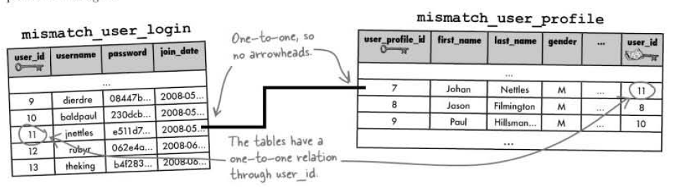

Fig 16: One-to-One Schema Design

One-to-One: Exactly one row of a parent table is related to one row of a child table.

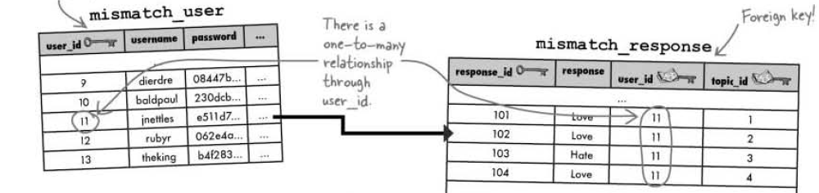

Fig 17: One-to-Many Schema Design

One-to-Many: Exactly one row of a parent table is related to multiple rows of a child table

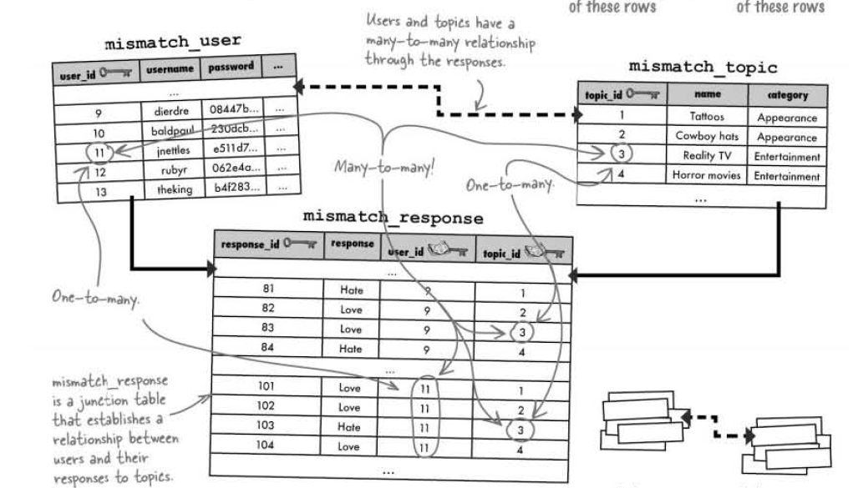

Fig 18: Many-to-Many Schema Design

Many-to-Many: Multiple rows of a parent table are related to multiple rows of child table

Response table is as **junction table,** by serving as a convenient go-between for the users and topics.

If we start with a well-designed database, every other piece of the application puzzle becomes that much easier to build and assemble.

**array_push()**

It tacks a new element onto the end of an array, causing the array to grow by one

<?php  
 $a=array("a"=>"red","b"=>"green");  
 array_push($a,"blue","yellow");  
 print_r($a);  
?>

**Solution:** Array ([a] => red [b] => green [0] => blue [1] => yellow)

**Foreach**

foreach($array as $key => $value){  
    // Code to be executed  
}

<?php

$superhero = **array**(

"name" => "Peter Parker",

"email" => "peterparker@mail.com",

"age" => 18

);

*// Loop through superhero array*

**foreach**($superhero **as** $key => $value){

**echo** $key . " : " . $value . "<br>";

}

?>

**Solution**

name : Peter Parker  
email : peterparker@mail.com  
age : 18

Code 45: foreach(key,value).php

**Data driven forms rely on data in a MySQL database to generate HTML form fields.**

The ternary ? : operator can be used to code if-else statements in a compact form

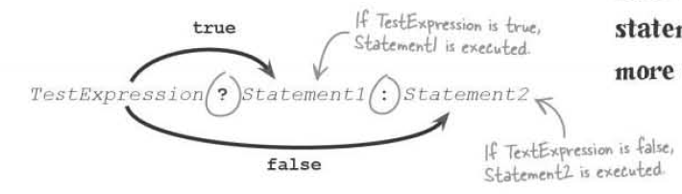

<?php

**require_once**("common/sessionstarter.php");

**require_once**("common/database.php");

*// Check if the cookier user id exists or not*

$cookie_user_id = $_COOKIE['user_id'];

**if**(!isset($cookie_user_id)):

$url = "http://".$_SERVER['HTTP_HOST'].dirname($_SERVER['PHP_SELF'])."/home.php";

header("Location: **$url**");

**endif**;

$connection = mysqli_connect($server_name, $user_name, $password, $db_name)

**or** **die**("Server Denied");

*/\*\**

*\**

*\* Filling up the mismatch_response with topic_ids w.r.t user_id*

*\**

*\*/*

*//Check whether the mismatch_response has any topic_id, response_id, response w.r.t user_id in the mismatch_response*

$query = "SELECT * FROM mismatch_response WHERE user_id = '**$cookie_user_id**'";

$result = mysqli_query($connection, $query) **or** **die**("User in Response Table Query Denied");

$topicIDs = **array**();

*//If the mismatch_response has no data, create topic_id w.r.t user_id*

**if**(mysqli_num_rows($result) == 0):

*//Selecting all the topic_id from the topic table*

$query = "SELECT topic_id from mismatch_topic ORDER BY topic_id";

$result = mysqli_query($connection, $query) **or** **die**("Collecting Topics Query Denied");

**while**($row = mysqli_fetch_array($result)){

array_push($topicIDs, $row['topic_id']);

}

*//Insert topic_id w.r.t user_id in the mismatch_response*

**foreach**($topicsIDS **as** $topic_id){

$query = "INSERT INTO mismatch_response(user_id, topic_id) VALUES('**$cookie_user_id**','**$topic_id**')";

mysqli_query($connection, $query) **or** **die** ("Inserting Topics Query Denied");

}

**endif**;

*//If the questionnaire form has been submitted, write the form responses to the database*

**if**(isset($_POST['submit'])):

**foreach**($_POST **as** $response_id => $response){

$query = "UPDATE mismatch_response SET response = '**$response**' WHERE response_id = '**$response_id**'";

mysqli_query($connection, $query) **or** **die** ("Updated the response Query Denied");

}

**endif**;

*/\*\**

*\**

*\* Fetching the response data from the database to generate form*

*\**

*\*/*

*//Collect response_id, topic_id, response w.r.t user_id from mismatch_response*

$query = "SELECT response_id, topic_id, response FROM mismatch_response WHERE user_id = '**$cookie_user_id**'";

$result = mysqli_query($connection, $query) **or** **die**("Fetching the data Query Denied");

$responses = **array**();

**while**($response_row = mysqli_fetch_array($result)){

$topic_id = $response_row['topic_id'];

*//Select name, category from the mismatch_topic using the mismatch_response topic_id*

$query2 = "SELECT name, category FROM mismatch_topic WHERE topic_id = '**$topic_id**'";

$topic_data = mysqli_query($connection, $query2) **or** ("Fetching category, name Query Denied");

*//Check if there is one topic_id that matches*

**if**(mysqli_num_rows($topic_data) == 1):

$topic_row = mysqli_fetch_array($topic_data);

$response_row['topic_name'] = $topic_row['name'];

$response_row['category_name'] = $topic_row['category'];

*//Feeding the topic name, category name to the $responses array*

array_push($responses, $response_row);

**endif**;

}

mysqli_close($connection);

*/\*\**

*\**

*\* Generate the questionnaire form by looping throung the response array*

*\**

*\*/*

**echo** "<form method = 'post' action ='".$_SERVER['PHP_SELF']."'>";

**echo** "<p> How do you feel about the each topic? </p>";

*//Display the first category*

$category = $responses[0]['category_name'];

**echo** "<h3>".$responses[0]['category_name']."</h3>";

**foreach**($responses **as** $response){

*//Change the category when the category for the response changes*

**if**($category != $response['category_name']):

$category = $response['category_name'];

**echo** "<h3>".$response['category_name']."</h3>";

**endif**;

*//Display the topic form fields*

**echo** "<label for = '".$response['response_id']."'>".$response['topic_name']." </label>";

**echo** "<input type = 'radio' name = '".$response['response_id']."' value = '1'"

.($response['response'] == 1?'checked="checked"' : '')."/>Love";

**echo** "<input type = 'radio' name = '".$response['response_id']."' value = '2'"

.($response['response'] == 2?'checked="checked"' : '')."/>Hate<br/>";

}

**echo** "<br/><input type = 'submit' value = 'Save' name = 'submit'/>";

**echo** "</form>";

?>

Code 45: question.php

**STEPS**

1. Check whether the mismatch_response has any topic_id, response_id, response w.r.t user_id in the mismatch_response
2. If the mismatch_response has no data, create topic_id w.r.t user_id
3. Selecting all the topic_id from the topic table
4. Insert topic_id w.r.t user_id in the mismatch_response
5. If the questionnaire form has been submitted, write the form responses to the database
6. Collect response_id, topic_id, response w.r.t user_id from mismatch_response
7. Select name, category from the mismatch_topic using the mismatch_response topic_id
8. Check if there is one topic_id that matches
9. Feeding the topic name, category name to the $responses array
10. Display the first category
11. Change the category when the category for the response changes
12. Display the topic form fields

#### Normalization

Normalization means designing a database to reduce duplicate data and improve the relationships between data.

Thinking Process:

* The main thing that we want table to be about
* How will we use the table, list of information that we are going to need about that one thing?
* How can we easily query the table?

Atomic data is data that has been broken down into the smallest form needed for a given database. Making our data atomic is the first step in creating a normal table.

Normalization has its benefits, namely improvements in database size and speed. Normal tables won’t have duplicate data which will reduce the size of our database. With less data to search through, our queries will be faster. Normalizing database involves strictly adhering to a series of design steps.

1. Columns should be atomic
2. Each table should have its own primary key
3. Making sure that the non-key columns aren’t dependent on each other.

More tables lead to less messier queries.

A join grabs results from multiple tables in a single query. In an INNER JOIN, it selects two rows from two tables based on a condition.

SELECT mismatch_topic.topic_id, mismatch_category.name

FROM mismatch_topic

INNER JOIN mismatch_category

ON (mismatch_topic.category_id = mismatch_category.category_id)

Dot notation allows us to reference the table a column belongs to within a join.

An INNER JOIN combines rows from two tables using comparison operators in a condition

SELECT mismatch_topic.topic_id, mismatch_category.name

FROM mismatch_topic

INNER JOIN mismatch_category

ON (mismatch_topic.category_id = mismatch_category.category_id)

WHERE mismatch_topic.name = “Easy Listening Music”

Rewrite on with using for more concise inner join queries that match on a common column. The column names must be the same in order to use the USING statement in an inner join.

SELECT mismatch_topic.topic_id, mismatch_category.name

FROM mismatch_topic

INNER JOIN mismatch_category

USING (category_id)

WHERE mismatch_topic.name = “Easy Listening Music”

An **Alias** allows us to rename a table or column within a query to help simplify the query in some way. When a column is renamed with an alias the alias is what appears in the query results.

SELECT mt.topic_id, mc.name

FROM mismatch_topic AS mt

INNER JOIN mismatch_category AS mc

USING (category_id)

WHERE mt.name = “Easy Listening Music”

**Joins** are more efficient and require less code than nested queries. Other types of **Inner Joins** include equijoins, non-equijoins and natural joins. **Equijoins** when the query search for equal columns. **Non-Equijoins** are inequality comparison. **Natural joins** involve comparing all columns that have the same name between two tables. There are several **Outer Joins, Left Outer Join, Right Outer Join, Full Outer Join.** In outer join the rows in the joined table don’t have to match, in order to make it into the join.

**Foreign Key**

CREATE TABLE Orders (  
    OrderID int NOT NULL,  
    OrderNumber int NOT NULL,  
    PersonID int,  
    PRIMARY KEY (OrderID),  
    FOREIGN KEY (PersonID) REFERENCES Persons(PersonID)  
);

The following SQL creates a **FOREIGN KEY** on the "PersonID" column when the "Orders" table is created:

ALTER TABLE Orders  
ADD FOREIGN KEY (PersonID) REFERENCES Persons(PersonID);

SQL FOREIGN KEY on ALTER TABLE

ALTER TABLE Orders  
DROP FOREIGN KEY FK_PersonOrder;

Drop FOREIGN KEY

**Array Slice**

array_slice(array,start,length,preserve)

<?php  
 $a=array("red","green","blue","yellow","brown");  
 print_r(array_slice($a,2));  
?>

Solution:: Array ( [0] => blue [1] => yellow [2] => brown )

Code 46: array_slice.php

### Search

MySQL searches are by default case-insensitive. SQL queries can be flexible with LIKE

SELECT job_id title, description FROM jobs WHERE title LIKE ‘%fighter’

The keyword LIKE lets us look for matches that aren’t exactly the same as the word in quotes and still case-insensitive. The % signs are **wildcards,** they stand in any other characters before or after the word. LIKE match the search search as part of a larger word or phrase.

LIKE ‘ _ _ _ _ fighters%’

Find the string fighter with any four characters in front of it, and any characters after it.

<?php

**require_once**("common/database.php");

$connection = mysqli_connect(SERVER, USER, PASS, DB);

**echo** "<!doctype html>";

**echo** " <html>";

**echo** " <head>";

**echo** " <title> Job Search Engine </title>";

**echo** " <meta charset = 'UTF-8'/>";

**echo** " </head>";

**echo** " <body>";

**echo** " <form method = 'post' action = '".$_SERVER['PHP_SELF']."'>";

**echo** " <label for = 'search'> Jobs, that you are looking for? </label><br/>";

$search = !**empty**($_POST['search'])? $_POST['search'] : '';

**echo** " <input type = 'text' name = 'search' value = '**$search**'/>";

**echo** " <input type = 'submit' name = 'submit' value = 'Search'/>";

**echo** " </form>";

**echo** " </body>";

**echo** " </html>";

**if**(isset($_POST['submit'])):

**if**(!**empty**($_POST['search'])){

$search = mysqli_real_escape_string($connection, trim($_POST['search']));

$query = "SELECT * FROM riskyjobs WHERE description LIKE '%**$search**%'";

$result = mysqli_query($connection, $query) **or** **die** ("Search Query Denied");

**echo** "<table>";

**echo** "<tr>";

**echo** " <th>Title</th>";

**echo** " <th>Description</th>";

**echo** " <th>City</th>";

**echo** " <th>State</th>";

**echo** " <th>Zip</th>";

**echo** " <th>Company</th>";

**echo** " <th>Date Posted</th>";

**while**($row = mysqli_fetch_array($result)){

**echo** "<tr>";

**echo** " <td>".$row['title']."</td>";

**echo** " <td>".$row['description']."</td>";

**echo** " <td>".$row['city']."</td>";

**echo** " <td>".$row['state']."</td>";

**echo** " <td>".$row['zip']."</td>";

**echo** " <td>".$row['company']."</td>";

**echo** " <td>".$row['date_posted']."</td>";

**echo** "</tr>";

}

**echo** "</table>";

}

**else**{

$error = "You cannot leave the search box empty!";

**echo** "<span>".$error."</span>";

}

**endif**;

?>

Code 46: search.php

#### Break Up the Phrases

The **explode()** function breaks a string into an array of substrings.

Ex: $search_words = explode(‘ ‘, ‘Hulk Hogan’);

The $search_words variable now stores the array of search terms. ‘ ‘ 🡪 This is what separated the substrings within the string, in this case a space. We can specify one or more characters, which are called **delimiter**.

The **implode()** function takes an array of strings and builds a single string out of them.

Ex: $string_attach = implode(‘-‘, $list);

$together = ‘’;

$lists = [‘apple’, ‘orange’, ‘banana’];

foreach($lists as $item){

$together .= $item;

}

echo($together);

**Solution:** appleorangebanana

Code 47: stringattach.php

<?php

**require_once**("common/database.php");

$connection = mysqli_connect(SERVER, USER, PASS, DB);

**echo** "<!doctype html>";

**echo** " <html>";

**echo** " <head>";

**echo** " <title> Job Search Engine </title>";

**echo** " <meta charset = 'UTF-8'/>";

**echo** " </head>";

**echo** " <body>";

**echo** " <form method = 'post' action = '".$_SERVER['PHP_SELF']."'>";

**echo** " <label for = 'search'> Jobs, that you are looking for? </label><br/>";

$search = !**empty**($_POST['search'])? $_POST['search'] : '';

**echo** " <input type = 'text' name = 'search' value = '**$search**'/>";

**echo** " <input type = 'submit' name = 'submit' value = 'Search'/>";

**echo** " </form>";

**echo** " </body>";

**echo** " </html>";

**if**(isset($_POST['submit'])):

**if**(!**empty**($_POST['search'])){

$search = mysqli_real_escape_string($connection, trim($_POST['search']));

$search_words = explode(' ', $search);

**echo** "<table>";

**echo** "<tr>";

**echo** " <th>Title</th>";

**echo** " <th>Description</th>";

**echo** " <th>City</th>";

**echo** " <th>State</th>";

**echo** " <th>Zip</th>";

**echo** " <th>Company</th>";

**echo** " <th>Date Posted</th>";

**echo** "</tr>";

*// foreach($search_words as $search){*

*// $query = "SELECT * FROM riskyjobs WHERE description LIKE '%$search%'";*

*// $result = mysqli_query($connection, $query) or die ("Search Query Denied");*

*// while($row = mysqli_fetch_array($result)){*

*// echo "<tr>";*

*// echo " <td>".$row['title']."</td>";*

*// echo " <td>".$row['description']."</td>";*

*// echo " <td>".$row['city']."</td>";*

*// echo " <td>".$row['state']."</td>";*

*// echo " <td>".$row['zip']."</td>";*

*// echo " <td>".$row['company']."</td>";*

*// echo " <td>".$row['date_posted']."</td>";*

*// echo "</tr>";*

*// }*

*// }*

*/\*\**

*\* Alternatively*

*\*/*

$where_list = **array**();

**foreach**($search_words **as** $word){

$where_list[] = " description LIKE '%**$word**%' ";

}

$where_clause = implode('OR', $where_list);

**if**(!**empty**($where_clause)):

$where_clause = "WHERE **$where_clause**";

**endif**;

$query = "SELECT * FROM riskyjobs **$where_clause**";

$result = mysqli_query($connection, $query) **or** **die** ("Search Query Denied");

**while**($row = mysqli_fetch_array($result)){

**echo** "<tr>";

**echo** " <td>".$row['title']."</td>";

**echo** " <td>".$row['description']."</td>";

**echo** " <td>".$row['city']."</td>";

**echo** " <td>".$row['state']."</td>";

**echo** " <td>".$row['zip']."</td>";

**echo** " <td>".$row['company']."</td>";

**echo** " <td>".$row['date_posted']."</td>";

**echo** "</tr>";

}

**echo** "</table>";

}

**else**{

$error = "You cannot leave the search box empty!";

**echo** "<span>".$error."</span>";

}

**endif**;

?>

Code 47: brokenphrase.php

**Preprocessing data** allows us to remove unwanted characters and make the data easier to process.

str_replace(‘delimiter’, ‘replace_item’, $string);

The substring ‘delimiter’ gets replaced by ‘replace item’ in the string

<?php

**require_once**("common/database.php");

$connection = mysqli_connect(SERVER, USER, PASS, DB);

**echo** "<!doctype html>";

**echo** " <html>";

**echo** " <head>";

**echo** " <title> Job Search Engine </title>";

**echo** " <meta charset = 'UTF-8'/>";

**echo** " </head>";

**echo** " <body>";

**echo** " <form method = 'post' action = '".$_SERVER['PHP_SELF']."'>";

**echo** " <label for = 'search'> Jobs, that you are looking for? </label><br/>";

$search = !**empty**($_POST['search'])? $_POST['search'] : '';

**echo** " <input type = 'text' name = 'search' value = '**$search**'/>";

**echo** " <input type = 'submit' name = 'submit' value = 'Search'/>";

**echo** " </form>";

**echo** " </body>";

**echo** " </html>";

**if**(isset($_POST['submit'])):

**if**(!**empty**($_POST['search'])){

$search = mysqli_real_escape_string($connection, trim($_POST['search']));

$clean_words = str_replace(","," ",$search);

$search_words = explode(' ', $clean_words);

$final_words = **array**();

**foreach**($search_words **as** $words){

**if**(!**empty**($words)):

$final_words[] = $words;

**endif**;

}

**echo** "<table>";

**echo** "<tr>";

**echo** " <th>Title</th>";

**echo** " <th>Description</th>";

**echo** " <th>City</th>";

**echo** " <th>State</th>";

**echo** " <th>Zip</th>";

**echo** " <th>Company</th>";

**echo** " <th>Date Posted</th>";

**echo** "</tr>";

$where_list = **array**();

**foreach**($final_words **as** $word){

$where_list[] = " description LIKE '%**$word**%' ";

}

$where_clause = implode('OR', $where_list);

**if**(!**empty**($where_clause)):

$where_clause = "WHERE **$where_clause**";

**endif**;

$query = "SELECT * FROM riskyjobs **$where_clause**";

$result = mysqli_query($connection, $query) **or** **die** ("Search Query Denied");

**while**($row = mysqli_fetch_array($result)){

**echo** "<tr>";

**echo** " <td>".$row['title']."</td>";

**echo** " <td>".$row['description']."</td>";

**echo** " <td>".$row['city']."</td>";

**echo** " <td>".$row['state']."</td>";

**echo** " <td>".$row['zip']."</td>";

**echo** " <td>".$row['company']."</td>";

**echo** " <td>".$row['date_posted']."</td>";

**echo** "</tr>";

}

**echo** "</table>";

}

**else**{

$error = "You cannot leave the search box empty!";

**echo** "<span>".$error."</span>";

}

**endif**;

?>

Code 48: replacestring.php

substr(string, start, length)

The PHP function **substr()** function allows us to extract a portion of a string**.**

$string = “Hello world”

0 1 2 3 4 5 6 7 8 9

-10-9-8-7-6 -5-4 -3 -2 -1

substr($row['description'], 0,100)

substr($row['date_posted'], 0, 9)

#### Custom Functions

**Customs functions** allow us to organize a chunk of PHP code by name so that it can be easily reused.

A function is a block of code separate from the rest of our code that can execute where we want in our script.

<?php

**require_once**("common/database.php");

**require_once**("buildquery.php");

**require_once**("sort.php");

**require_once**("generate_sort_links.php");

$connection = mysqli_connect(SERVER, USER, PASS, DB);

**echo** "<!doctype html>";

**echo** " <html>";

**echo** " <head>";

**echo** " <title> Job Search Engine </title>";

**echo** " <meta charset = 'UTF-8'/>";

**echo** " </head>";

**echo** " <body>";

**echo** " <form method = 'get' action = '".$_SERVER['PHP_SELF']."'>";

**echo** " <label for = 'search'> Jobs, that you are looking for? </label><br/>";

$search = !**empty**($_GET['search'])? $_GET['search'] : '';

**echo** " <input type = 'text' name = 'search' value = '**$search**'/>";

**echo** " <input type = 'submit' name = 'submit' value = 'Search'/>";

**echo** " </form><br/>";

**echo** " </body>";

**echo** " </html>";

**if**(isset($_GET['submit'])):

**if**(!**empty**($_GET['search'])){

$sortby = (!**empty**($_GET['sort'])) ? $_GET['sort'] : 1;

**echo** generate_sort_links($_GET['search'], $sortby);

$search = mysqli_real_escape_string($connection, trim($_GET['search']));

$where_clause = build_query($search);

$order_by = sorting($sortby);

$query = "SELECT * FROM riskyjobs **$where_clause** **$order_by**";

$result = mysqli_query($connection, $query) **or** **die** ("Search Query Denied");

**echo** "<table>";

**echo** "<tr>";

**echo** " <th>Title</th>";

**echo** " <th>Description</th>";

**echo** " <th>City</th>";

**echo** " <th>State</th>";

**echo** " <th>Zip</th>";

**echo** " <th>Company</th>";

**echo** " <th>Date Posted</th>";

**echo** "</tr>";

**while**($row = mysqli_fetch_array($result)){

**echo** "<tr>";

**echo** " <td>".$row['title']."</td>";

**echo** " <td>".substr($row['description'], 0,100)."</td>";

**echo** " <td>".$row['city']."</td>";

**echo** " <td>".$row['state']."</td>";

**echo** " <td>".$row['zip']."</td>";

**echo** " <td>".$row['company']."</td>";

**echo** " <td>".substr($row['date_posted'], 0, 9)."</td>";

**echo** "</tr>";

}

**echo** "</table>";

}

**else**{

$error = "You cannot leave the search box empty!";

**echo** "<span>".$error."</span>";

}

**endif**;

?>

Code 49: replacestring.php

<?php

**function** build_query($post_search){

$clean_words = str_replace(","," ",$post_search);

$search_words = explode(' ', $clean_words);

$final_words = **array**();

**foreach**($search_words **as** $words){

**if**(!**empty**($words)):

$final_words[] = $words;

**endif**;

}

$where_list = **array**();

**foreach**($final_words **as** $word){

$where_list[] = " description LIKE '%**$word**%' ";

}

$where_clause = implode('OR', $where_list);

**if**(!**empty**($where_clause)):

$where_clause = "WHERE **$where_clause**";

**endif**;

**return** $where_clause;

}

?>

Code 50: buildquery.php

<?php

**function** sorting($sortby){

$string = 'ORDER BY ';

**switch**($sortby){

**case** 1:

$string .= " title ASC";

**break**;

**case** 2:

$string .= " title DESC";

**break**;

**case** 3:

$string .= " state ASC";

**break**;

**case** 4:

$string .= " state DESC";

**break**;

**case** 5:

$string .= " date_posted ASC";

**break**;

**case** 6:

$string .= " date_posted DESC";

**break**;

**default**:

}

**return** $string;

}

?>

Code 51: sort.php

<?php

**function** generate_sort_links($user_search, $sort){

$string = '';

$self = $_SERVER['PHP_SELF'];

**switch**($sort){

**case** 1:

$string .= "<p><a href = '".$self."?search=".$user_search."&amp;sort=2&amp;submit=1'>Job Title</a> /";

$string .= "<a href = '".$self."?search=".$user_search."&amp;sort=3&amp;submit=1'>State</a> /";

$string .= "<a href = '".$self."?search=".$user_search."&amp;sort=5&amp;submit=1'>Date Posted</a></p>";

**break**;

**case** 3:

$string .= "<p><a href = '".$self."?search=".$user_search."&amp;sort=1&amp;submit=1'>Job Title</a> / ";

$string .= "<a href = '".$self."?search=".$user_search."&amp;sort=4&amp;submit=1'>State</a> / ";

$string .= "<a href = '".$self."?search=".$user_search."&amp;sort=5&amp;submit=1'>Date Posted</a></p>";

**break**;

**case** 5:

$string .= "<p><a href = '".$self."?search=".$user_search."&amp;sort=1&amp;submit=1'>Job Title</a> / ";

$string .= "<a href = '".$self."?search=".$user_search."&amp;sort=3&amp;submit=1'>State</a> / ";

$string .= "<a href = '".$self."?search=".$user_search."&amp;sort=6&amp;submit=1'>Date Posted</a></p>";

**break**;

**default**:

$string .= "<p><a href = '".$self."?search=".$user_search."&amp;sort=1&amp;submit=1'>Job Title</a> / ";

$string .= "<a href = '".$self."?search=".$user_search."&amp;sort=3&amp;submit=1'>State</a> / ";

$string .= "<a href = '".$self."?search=".$user_search."&amp;sort=5&amp;submit=1'>Date Posted</a></p>";

}

**return** $string;

}

?>

Code 52: generate_sort_links.php

#### Pagination

**Pagination** breaks query results into sets, and display search set on its own web page. Limit controls what and how many rows are returned by an SQL query. When two arguments are given to the Limit SQL, the first arguments controls how many rows we skip, and the second argument controls how many rows we get back.

SELECT FROM table_name WHERE COLUMN = match LIMIT num(skip) num(show)

<?php

**function** generate_page_links($user_search, $sortby, $cur_page, $num_pages){

$string = '';

$self = $_SERVER['PHP_SELF'];

$previous = $cur_page - 1;

$next = $cur_page + 1;

*//If this is not the first page, generate the "Previous Links"*

**if**($cur_page > 1){

$string .= "<p><a href = '".$self."?search=".$user_search."&amp;sort=**$sortby**&amp;submit=1"

."&amp;page=**$previous**'><--</a>";

}

**else**{

$string .=' ';

}

**for**($i = 1; $i <= $num_pages; $i++){

$string .= "<a href = '".$self."?search=".$user_search."&amp;sort=**$sortby**&amp;submit=1"

."&amp;page=**$i**'>**$i**</a>";

}

**if**($cur_page < $num_pages){

$string .= "<a href = '".$self."?search=".$user_search."&amp;sort=**$sortby**&amp;submit=1"

."&amp;page=**$next**'>--></a></p>";

}

**else**{

$string .=' ';

}

**return** $string;

}

?>

Code 52: generate_pagination_links.php

<?php

**require_once**("common/database.php");

**require_once**("buildquery.php");

**require_once**("sort.php");

**require_once**("generate_sort_links.php");

**require_once**("generate_page_links.php");

$connection = mysqli_connect(SERVER, USER, PASS, DB);

**echo** "<!doctype html>";

**echo** " <html>";

**echo** " <head>";

**echo** " <title> Job Search Engine </title>";

**echo** " <meta charset = 'UTF-8'/>";

**echo** " </head>";

**echo** " <body>";

**echo** " <form method = 'get' action = '".$_SERVER['PHP_SELF']."'>";

**echo** " <label for = 'search'> Jobs, that you are looking for? </label><br/>";

$search = !**empty**($_GET['search'])? $_GET['search'] : '';

**echo** " <input type = 'text' name = 'search' value = '**$search**'/>";

**echo** " <input type = 'submit' name = 'submit' value = 'Search'/>";

**echo** " </form><br/>";

**echo** " </body>";

**echo** " </html>";

**if**(isset($_GET['submit'])):

**if**(!**empty**($_GET['search'])){

*//Sort value from GET*

$sortby = (!**empty**($_GET['sort'])) ? $_GET['sort'] : 1;

*//Generating the links to order the query*

**echo** generate_sort_links($_GET['search'], $sortby);

*//Get the search data*

$search = mysqli_real_escape_string($connection, trim($_GET['search']));

*//Clean up the data*

$where_clause = build_query($search);

*//Sort the data*

$order_by = sorting($sortby);

*//Find out the number of rows*

$query = "SELECT * FROM riskyjobs **$where_clause** **$order_by**";

$result = mysqli_query($connection, $query) **or** **die** ("Total Query Denied");

*//Calculating the LIMIT skip for the query*

$cur_page = isset($_GET['page'])? $_GET['page']: 1;

$results_per_page = 5;

$skip = ($cur_page - 1) * $results_per_page;

$total_query = mysqli_num_rows($result);

$num_pages = ceil($total_query/$results_per_page);

*//Generate pagination link*

**echo** generate_page_links($_GET['search'], $sortby, $cur_page, $num_pages);

$query = "SELECT * FROM riskyjobs **$where_clause** **$order_by** LIMIT **$skip**, **$results_per_page**";

**echo** $query;

$result = mysqli_query($connection, $query) **or** **die** ("Search Query Denied");

**echo** "<table>";

**echo** "<tr>";

**echo** " <th>Title</th>";

**echo** " <th>Description</th>";

**echo** " <th>City</th>";

**echo** " <th>State</th>";

**echo** " <th>Zip</th>";

**echo** " <th>Company</th>";

**echo** " <th>Date Posted</th>";

**echo** "</tr>";

**while**($row = mysqli_fetch_array($result)){

**echo** "<tr>";

**echo** " <td>".$row['title']."</td>";

**echo** " <td>".substr($row['description'], 0,100)."</td>";

**echo** " <td>".$row['city']."</td>";

**echo** " <td>".$row['state']."</td>";

**echo** " <td>".$row['zip']."</td>";

**echo** " <td>".$row['company']."</td>";

**echo** " <td>".substr($row['date_posted'], 0, 9)."</td>";

**echo** "</tr>";

}

**echo** "</table>";

}

**else**{

$error = "You cannot leave the search box empty!";

**echo** "<span>".$error."</span>";

}

**endif**;

?>

Code 52: replacestring.php

ceil($total_query/$results_per_page)

This rounds up the value

### PHP Terms

mail($to, $subject, $message, 'From:'.$email)

Send email

$conn = mysqli_connect($server_name, $username, $password, $database_name)

Connect PHP script with the server

mysqli_close($conn)

Closes the connection with the server

mysqli_query($conn, $query)

Sends MySQL Query to the server

mysqli_select_db($connection, $databasename)

It is used to change the default database for the connection

$result = mysqli_query($conn, $query)

mysqli_fetch_array($result)

It retrieves a single row of data from the results of a database query

isset()

Variable exists or not, any value is assigned to it or not

empty()

Checks whether the variable contains 0, NULL, FALSE or an empty string

include(“file_path”), include_once(“file_path”)

require(“file_path”), require_once(“file_path”)

Share script code across multiple files.

$_FILES

It is a built-in super global variable provides access to information about uploaded files.

$_FILES[‘image’][‘name’]

The name of the uploaded file

$_FILES[‘image’][‘type’]

MIME type of the uploaded file

$_FILES[‘image’][‘tmp_name’]

Temporary storage location of the file on the server

$_FILES[‘error’][‘error’]

The error code for the file upload, 0 indicates a success, other values indicate failure

move_uploaded_file($_FILES[‘image’][‘tmp_name’], $target)

Move file from temporary location to the targeted location

trim($POST[‘name’])

Eliminates Leading or trailing spaces

mysqli_real_escape_string($connection, trim($_POST[‘name]));

It converts dangerous characters into an escaped format that won’t adversely affect SQL queries.

header(’Location:http://www.addinventory.php’);

The header is called a location header and redirects the current page to addinventory.php

header(’Refresh: 5; url=http://www.addinventory.php’);

This header is called a refresh header since it refreshes a page after a period of time.

header(’Content-Type: text-plain’);

Context will be plain text

header('HTTP/1.1 401 Unauthorized');

This header lets the browser know that the user in not authorized to view the page

header('WWW-Authenticate: Basic realm="Store"');

Basic realm is just a phrase used to uniquely identify this. Particular authentication-it appears in the authentication window.

setcookie($cookie_name, $cookie_value, time() + (86400 * 30), "/");

The cookie will expire after 30 days (86400 * 30). The "/" means that the cookie is available in entire website

dirname($_SERVER['PHP_SELF'])

/education/Php/7. Personal Web Application

$_SERVER['HTTP_HOST']

Localhost

session_start(), session_destroy(), session_name()

Checks the session id

array_push()

It tacks a new element onto the end of an array, causing the array to grow by one

array_slice(array,start,length,preserve)

Starts the array from the start the position

explode(‘delimiter’, ‘phrase’)

Delimiter separates the words in the phrase

implode(‘delimiter’, ‘items’)

Combines the string in the items array by adding delimiter after each item

str_replace(‘delimiter’, ‘replace_item’, $string);

The substring ‘delimiter’ gets replaced by ‘replace item’ in the string

substr(string, start, length)

The PHP function **substr()** function allows us to extract a portion of a string**.**

ceil($total_query/$results_per_page)

This rounds up the value

### SQL Terms

DROP TABLE table_name

DESCRIBE table_name

SELECT * FROM table_name

DELETE FROM table_name

ALTER TABLE table_name ADD COLUMN column_name column_type

ALTER TABLE table_name CHANGE COLUMN old_column new_column new_column_type

ALTER TABLE table_name DROP COLUMN column_name

ALTER TABLE table_name MODIFY COLUMN column_name column_type AFTER column_nam

SELECT * FROM table_name ORDER BY column ASC/DESC

DELETE FROM table_name WHERE COLUMN = match LIMIT num

INSERT INTO table_name(column_name…) VALUES(column_values…)

UPDATE table_name SET column_name = some_value WHERE column_name = some_value

SELECT mismatch_topic.topic_id, mismatch_category.name

FROM mismatch_topic

INNER JOIN mismatch_category

USING (category_id)

WHERE mismatch_topic.name = “Easy Listening Music”

CREATE TABLE Orders (  
    OrderID int NOT NULL,  
    OrderNumber int NOT NULL,  
    PersonID int,  
    PRIMARY KEY (OrderID),  
    FOREIGN KEY (PersonID) REFERENCES Persons(PersonID)  
);

ALTER TABLE Orders  
ADD FOREIGN KEY (PersonID) REFERENCES Persons(PersonID);

ALTER TABLE Orders  
DROP FOREIGN KEY FK_PersonOrder;

SELECT job_id title, description FROM jobs WHERE title LIKE ‘%fighter%’

SELECT FROM table_name WHERE COLUMN = match LIMIT num(skip) num(show)

### Homework

1. Combine HTML(form.html) and PHP file(report.php) into one PHP file (form.php)
2. Edit (addemail.php, addemail.html) into one PHP file(addemailupdated.php) and this time only unique email addresses would be added to the database.
3. Edit (filevalidation.php) to make it more robust.
4. Add approve and unapproved to the store files.
5. Add Validation to the Personal Web Application files.
6. Change the authentication from cookies to session for personal web application.
7. Revamp the templates for the personal web application

## GitHub

GitHub is a code hosting platform for version control and collaboration. It lets us work together on projects from anywhere. Create a GitHub account first.

### STEP 1: Create a Repository

It is usually used to organize a single project. Repositories can contain folders and files, images, videos, spreadsheet, and data-sets anything that our project needs

* In the upper right corner, next to your avatar or identicon, click + and then select New repository.
* Name your repository hello-world.
* Write a short description.
* Select Initialize this repository with a README.

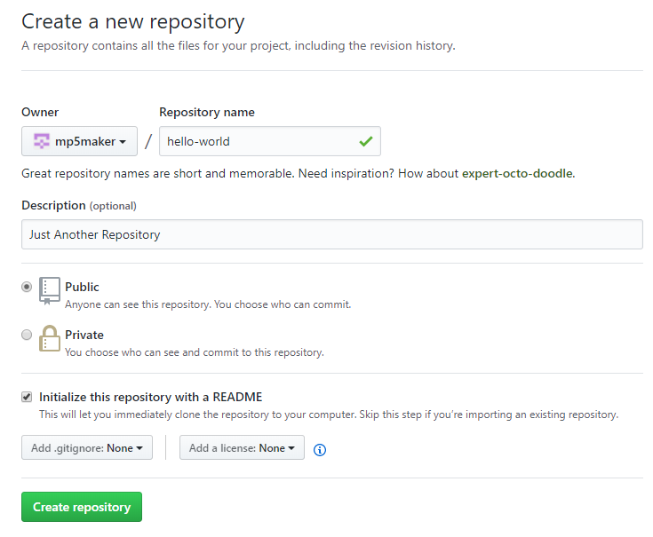

Fig 1. GitHub, Creating New Repository

### STEP 2: Branching

It is the way to work on different versions of a repository at one time. By default, our repository has one branch named master which is considered to be the definitive branch. We use branches to experiment and make edits before committing them to master. When we create a branch off the master branch, you’re making a copy, or snapshot, of master as it was at that point in time. If someone else made changes to the master branch while we were working on your branch, we could pull in those updates.

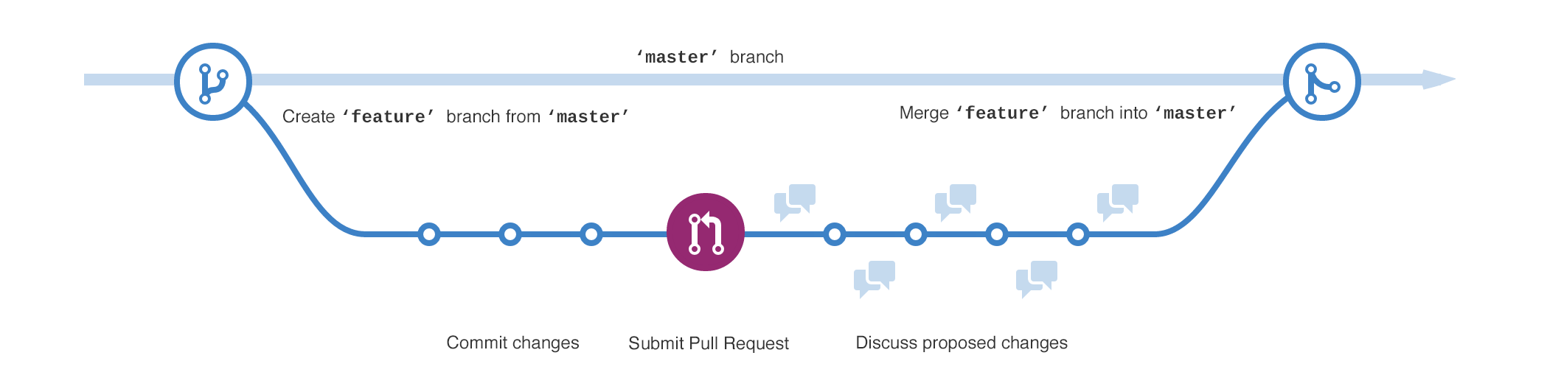

Fig 2. GitHub, Branching

#### To create a new branch

Go to your new repository hello-world.

Click the drop down at the top of the file list that says branch: master.

Type a branch name, readme-edits, into the new branch text box.

Select the blue Create branch box or hit “Enter” on your keyboard.

Now we have two branches, master and readme-edits. They look exactly the same. Next, we’ll add our changes to the new branch.

### STEP 3: Commit Changes

We are on the code view for our readme-edits branch, which is a copy of master.

On GitHub, **saved changes** are called **commits**. Each commit has an associated commit message, which is a description explaining why a particular change was made. Commit messages capture the history of our changes, so other contributors can understand what we have done and why.

### STEP 4: Open a Pull Request

When we open a pull request, we are proposing our changes and requesting that someone review and pull in your contribution and merge them into their branch. Pull requests show diffs, or differences, of the content from both branches. The changes, additions, and subtractions are shown in green and red.

As soon as we make a commit, we can open a pull request and start a discussion, even before the code is finished. By using GitHub’s **@mention** system in your pull request message, you can ask for feedback from specific people or teams. We can even open pull requests in your own repository and merge them ourselves.

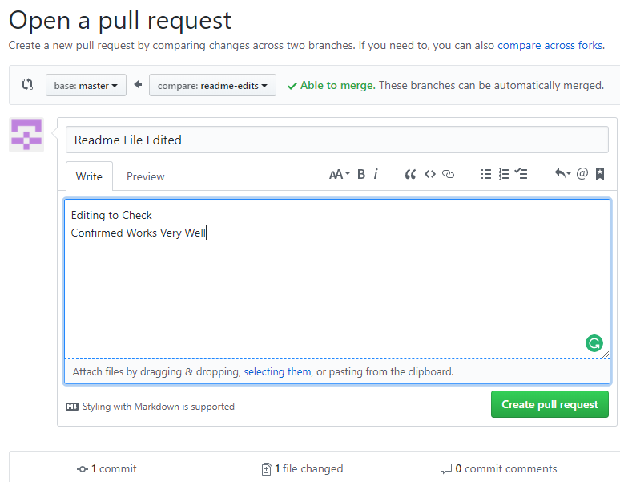

Fig 3. GitHub, Open a Pull Request

### STEP 5: Merge our Pull Request

In this final step, it’s time to bring our changes together – merging our readme-edits branch into the master branch.

Click the green Merge pull request button to merge the changes into master.

Click Confirm merge.

Go ahead and delete the branch, since its changes have been incorporated, with the Delete branch button in the purple box.

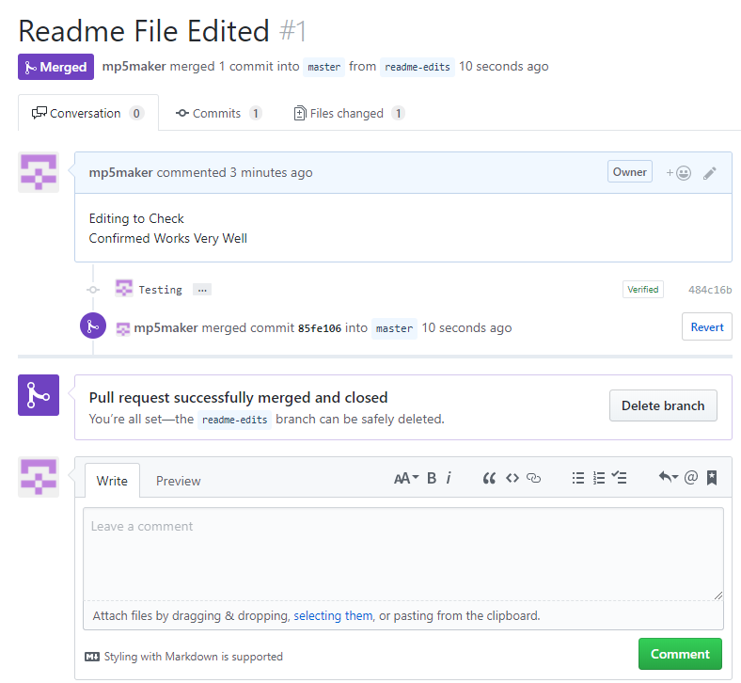

Fig 4. GitHub, Merge the Pull Request